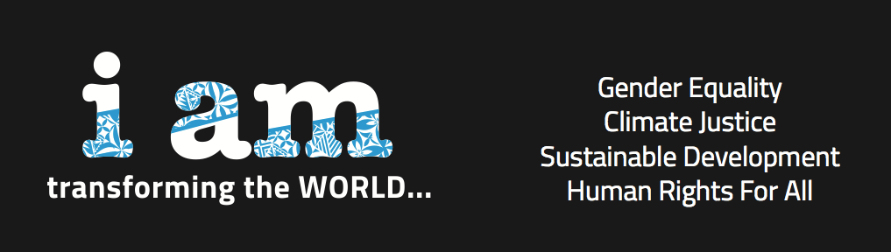

Pacific Partnerships

to Strengthen Gender, Climate Change Response and Sustainable Development
9-13 June 2014
Nadi, Fiji

REPORT

Meeting convened by:
Secretariat of the Pacific Community (SPC)
Diverse Voices and Action for Equality (DIVA)

Partners:
United Nations Entity for Gender Equality and the Empowerment of Women (UN Women)
Development Alternatives with Women for a New Era (DAWN)
Pacific Youth Council (PYC)
Fiji Women’s Rights Movement (FWRM)
Women’s Major Group (WMG)
Global Fund for Women
Dag Hammarskjöld Foundation

Report prepared by Kathryn Tobin

Table of Contents

Day 1 – Monday, June 9

Opening Remarks……………………………………….…………………………………………………………………………..…3 Introductory Presentations……………..…………………………………………………………………………………………3 Mini-Statements and Group Work…………….……………………………………………………………………………….6

Day 2 – Tuesday, June 10

Report-back from Youth Congress……………………………………………………….…………………………………………7 Feminist Interlinkage and Intersectional Analysis...…..………………………………………………………..…………7 Mapping CSO Roles in Advocacy Processes…..……………………………………….……………………………………….8 Smart and Strong Analysis, Advocacy, and Movement-Building…………………………….………………………..9 Presentation of Mini-Statements….……………………………………………………….……………………………………….9

Day 3 – Wednesday, June 11

Initiating Strategic Dialogues……………………………………………………………………………………………………..10 Examining Partnerships……………………………………………………………………………………………………………..11 SIDS: Barbados Programme of Action and Mauritius Strategy of Implementation…………………………11 More than the Money: Loss and Damage, Climate Finance, and More?...…………………………………….12 Tips and Tricks for Effective Advocacy and Lobbying……….…………….…………………………………………….14

Day 4 – Thursday, June 12

The Human Rights Normative Framework for Gender Equality and Women’s Human Rights…….....15 Pacific Dinner Dialogue on Gender Equality, Climate Change, and Sustainable Development.………16

Day 5 – Friday, June 13

Meeting Commencement and Chair Introductions……………………………………………………………….……….17
Gains, Challenges and Possibilities: Visions of Pacific Gender, Climate and Development Justice….18 Global Processes: Gender, Climate Change, and Sustainable Development.………………………………....19
Championing Change for Gender, Climate Change and Sustainable Development………………………..20

Annex I. Outcome Statement – Civil Society………………………………………………………………………..21
Annex II. Outcome Statement – Civil Society and National Women’s Machineries………………26
Annex III. Concept Note……………………………………………………………………………..……………………….29
Annex IV. Agenda…………………………………………………………………………………………………….………….32
Annex V. Participants’ List………………………………………………………………………………………….……….37
Annex VI. Background Documents and Conference Resources…………………………………………….40
Annex VII. Videos of the Conference……………………………………………………………….………………….45
Annex VIII. PPGCCSD on Social Media………………………………………….…………………………………..…46
Annex IX. Key Themes Raised at the Conference………………………….…………………………………..…47
Annex X. Work of the Drafting Committee……….………………………….………………………………..……50

Day 1 – Monday, June 9

Opening Remarks

Brigitte Leduc, Gender Adviser at the Secretariat for the Pacific Community (SPC), began the conference by sharing the rationale for its planning, which originated at the 12th Triennial Conference of Pacific Women. There, the idea of bringing representatives of civil society organizations (CSOs) together with governments to discuss gender and climate change as interlinked priorities was raised, along with the fundamental importance of ensuring that the concerns and aspirations of Pacific women are reflected in the myriad of ongoing development processes. Siloes exist not only within civil society but also within the institutional mechanisms that address a range of development issues, Brigitte asserted; the objective of the PPGCCSD meeting was to break down those siloes by promoting a shared understanding of the interlinkages between gender equality, climate change response, and disaster risk reduction (DRR), towards a transformative agenda based on human rights, justice, and equality. The emphasis on partnerships, she continued, encompasses CSOs and the institutional mechanisms tasked with promoting gender equality along with other allies, to carry regional priorities and specific messages forward in a range of fora and at local, regional, and global levels.

Noelene Nabulivou of Diverse Voices and Action (DIVA) for Equality, Development Alternatives with Women for a New Era (DAWN), and the Women’s Major Group added that the meeting was organized as an example of how to build partnerships, while simultaneously strengthening capacity to link and bolster advocacy related to the topics of the meeting. A networked, solidarity-based response is necessary to address the challenges of climate change and sustainable development, Noelene stressed. She concluded with a slogan of the Planeta Femea tent at the Earth Summit in 1992: We make life the center of all politics, and all ethics, and all practice.

Introductory Presentations

The substance of Day 1 began with a lecture on climate change by Helene Jacot Des Combes of the Pacific Centre for Environment and Sustainable Development at University of the South Pacific. Helene explained the fundamentals of climate change science, provided an overview of the effects of climate change on the Pacific region, and outlined detailed scenarios of what could happen if climate change is or is not addressed. Illustrating the impacts of climate change on flooding, coastal erosion, water security, food security, and health, Helene proposed several options for climate change adaptation in the Pacific. Adaptation is everyone’s business, Helene concluded, emphasizing the need for all people – particularly women – to contribute their skills and knowledge towards climate change adaptation and resilience.

In the discussion after Helene’s presentation, Imogen Ingram of Island Sustainability Alliance and the International Network for the Elimination of POPs raised the issue of the revolitization of chemicals (POPs) caused by global warming, as an argument in favor of reducing not just greenhouse gas emissions but all chemical outputs. Several participants highlighted the need for increased funding and other resources, for both adaptation and emergency response. Helene emphasized the diversity of the ocean environment and the necessity of employing local knowledge to ensure the hardiness of seedlings, for example. Regarding funding, she pointed to the difficulty of determining what natural impacts are directly caused by climate change, and, once this is determined, actually receiving payment in accordance with the polluter pays principle. At the conclusion of this session, Noelene pointed out that Helene’s method of identifying the optimistic and pessimistic scenarios is a useful strategy for making a political point, especially when the science to support one’s argument is still being negotiated.

Cecilia Aipira of UN Women’s Pacific regional office gave a presentation on climate change, DRR, and gender equality. In the Pacific, an estimated 60% of disasters are climate-related, and 4 million people in the region are also affected by tropical cyclones and droughts, she explained; despite these statistics, Pacific countries have only been able to access 36% of available money under the LDC Fund. Cecilia emphasized the distinction between DRR and disaster response, which originates from a humanitarian perspective and receives a broad majority of available funding, as well as between DRR and climate change adaptation. While both DRR and climate change adaptation focus on reducing vulnerability and enhancing the resilience of communities, DRR includes non-climate related hazards (such as earthquakes and volcanoes) in addition to disasters caused by climate change, such as floods, storms, and droughts.

Regarding the links between DRR, climate change, and gender, Cecilia illustrated a long-term perspective that posits the need for prevention and attention to the particular vulnerabilities and contributions of women and girls. Women and girls are fourteen times more likely than men to die from disasters, and face both the tangible and intangible impacts of disasters, in part due to their higher relative reliance on natural resources, she outlined. A gender perspective, along with broader social considerations, should be adequately integrated into DRR and climate change policy, Cecilia asserted. She emphasized the need for evidence, including data disaggregated by sex and grounded in the participation of women, to support more effective climate change response and DRR policies. To accurately communicate risk, civil society working on the ground must raise their knowledge in arenas of policy formulation on DRR and climate change, at national, regional, and global levels, Cecilia concluded.

In the discussion following Cecilia’s presentation, Matelita Houa of Tongan Youth Congress and 350.org added that rapid assessment tools based on gender equality, water and sanitation, and other social priorities must be included in analyses of disasters. Women’s contributions before and after disasters, particularly in service delivery, should also be taken into account, according to Kairangi Samuela of Punaga Tauturu, Inc. Highlighting the need to expand disaster response beyond infrastructure, Christina Ora of Honiara Youth Council cited the example of Project Uplift, which enables young women and women within national ministries to tackle social issues arising from disasters and to participate in community-led rebuilding.

Adequate understanding of the environmental and economic impacts of DRR is necessary, cautioned Ann Kitalong of The Environment, Inc., and intra-regional learning is important in this regard. Adivasu Levu of femLINK Pacific emphasized that we cannot talk about climate change without talking about DRR; she shared knowledge from her work with Women’s Weather Watch in undertaking monthly consultations on environmental security. Finally, Sharmind Neelormi of Jahangirnagar University in Bangladesh pointed to the importance of including women in early warning systems and assessment of disasters. Cecilia concluded the session by identifying the need to influence funding flows while simultaneously collecting and analyzing relevant data, to ensure that social impacts are taken into consideration in both policies and programs for climate change and DRR.

Preparation and Presentation: Gender, Climate Change, and Sustainable Development

Noelene Nabulivou introduced the interlinkage analysis related to gender, climate change, and sustainable development. She explained DAWN’s feminist political economy approach and the understanding that issues of power and resources must be addressed to effect profound structural change. Accounting involves decisions being made about what matters and what doesn’t, Noelene continued; a big-picture, interlinkage analysis can bring out new and unexpected lessons, strategies, ideas, and processes. Collective thinking and mapping of political actors is important in identifying visionary and transformative strategies, particularly regarding long-term thinking, Noelene instructed. Through a historical perspective, she emphasized that we cannot talk about climate change and sustainable development unless we analyze the existing context for a diversity of women and girls. Simultaneously, we have to challenge the thinking of separations, towards Hayden’s conception of sustainable justice and Sen’s articulation of development as requiring the removal of sources of unfreedom.

Outlining priorities for the meeting, Noelene mentioned human rights as core to development, the intersectional approach and interlinkage analysis; the strategy of coalition analysis; the ecosphere approach that takes into account planetary boundaries; and using frames of diversity and fluidity. Finally, she cautioned that international justice is not the same as global justice, an important consideration particularly regarding climate change, which is a global – rather than a national – issue and therefore exists outside the typical political boundaries of state sovereignty.

To introduce relevant topics and set the stage for further discussion, Brigitte Leduc then led participants through a “gender quiz,” followed by a presentation. She outlined gender perspectives of vulnerability, including in relation to natural disasters, natural resources, food security, wellbeing (including the experience of displacement and conflict), and infrastructure and services. Women and men have different roles, capacities and constraints, and power, Brigitte illustrated; therefore, women and men have different needs and sensitivity to climate change impact. This sensitivity is determined by environmental factors and exposure to climate change, but also by economic, social, and cultural factors which together impact one’s status, behaviors, roles, relationships, power, and capacity. Social and cultural factors are much more constraining for women than for men, Brigitte explained, which makes women more vulnerable to the effects of climate change. This is evidenced through gender differences in deaths from natural disasters: where women’s rights are not protected, more women than men die from natural disasters, whereas where women and men enjoy equal rights, equal numbers of women and men are killed by disasters.

Climate change intrinsically affects human rights, including to life, health, food, water, personal security, nationality, and culture, Brigitte continued. Disadvantaged groups, persons with disabilities, people living in hardship, and women face higher risks in all of these areas, and therefore adaptive capacity must consider gender differences as well as relative access to resources/assets (financial and material), access to information, family support/networks/social capital, ability to make choices, mobility, training, and technologies. Gender inequality is therefore a crucial factor of vulnerability; increasing adaptive capacity for everyone, especially women, is an important priority for climate policy. Brigitte summarized her argument by explaining that exposure (in other words, the spaces that men and women occupy in society) and sensitivity (gender roles and livelihoods) combine to determine the impact of climate change. As women have always played a critical role in managing the natural resources, food security, and overall wellbeing of their households and communities, women are powerful agents of change and their leadership is critical. Brigitte stressed that collective advocacy must acknowledge the power and potential of women, rather than simply highlighting their increased vulnerability to climate change. She concluded by pointing to the need to promote women’s human rights and equality with men, as well as their participation in decision-making, as a contribution to building resilient communities and transforming the root causes of vulnerability to disasters and climate change.

Mini-Statements and Group Work

Noelene and Brigitte introduced the afternoon’s activity of group work towards individual mini-statements of 2-3 minutes, aimed at highlighting important issues related to participants’ work and priorities. Noelene outlined useful elements of a statement: an introduction that frames and justifies the ideas, and the main body of the paragraph, which includes its recommendations. She also suggested spending time to get the ideas and flow right, to better convince the reader and highlight the most important demands, including by referencing their sources. As preparation for individual mini-statements, participants broke into groups to begin to outline a) problems they work on, related to gender, social, economic, ecological concerns, along with strategies and lessons learned; and b) how these challenges interlink with each other and with climate change.

After spending some time working in groups, participants reported back on their discussions. The conversations mentioned the particular situation of Pacific SIDS and the need to address the impacts of climate change on the lives and livelihoods of Pacific women, young people, and persons with disabilities. Women should be the focus of capacity-building to adapt to climate change, one group asserted, and should hold adequate information and learning to respond to disasters and to mitigate the impacts of climate change. Communications plans and early warning systems that specifically target women and young people are necessary, another group added, to ensure greater reach and effectiveness of DRR strategies. Directing funding towards local knowledge and practices that support community resilience, DRR, integrity, health (including particular attention to non-communicable diseases), and wellbeing was also highlighted as a priority.

One group tied a variety of issues to broader conditions of inequality, which must be corrected for development and long-term wellbeing in the Pacific. Milikini Failautusi of Tuvalu Youth Council linked sexual and reproductive health and rights to climate change including through the specific vulnerabilities of young women, as disasters negatively impact social development and the availability of sexual and reproductive health services. Moia Tetoa of Aia Mwaea Ainen emphasized the importance of women’s participation in decision-making, both in ensuring a gender-balanced perspective and in carrying an interlinkage perspective of gender, climate change, and sustainable development. Finally, several participants emphasized that partnerships between governments, civil society, regional organizations, the private sector, and donor agencies will enable policy development and social mobilization at grassroots, national, and regional levels towards climate change adaptation and DRR projects that preserve Pacific cultural knowledge and skills and are inclusive of women and persons with disabilities.

Day 2 – Tuesday, June 10

Report-back from Youth Caucus

Christina Ora shared the results of the first meeting of the PPGCCSD Youth Caucus, which met daily under the guidance of Pacific Youth Council’s Tarusila Bradburgh. In addition to Christina (Solomon Islands), members of the Caucus were Erana Aliklik (Nauru), Kelvin Anthony (Fiji), Milikini Failautusi (Tuvalu), Brianna Freun (Samoa), Matelita Houa (Tonga), Ann Hubert (Nauru), Kim Sachs (Fiji), Camari Serau (Fiji), and Viva Tatawaqa (Fiji). Christina outlined that the first day of the conference had elicited insights on how to advocate in climate change arenas, taking into consideration the interlinkages between the various approaches. The youth caucus commented on the interactive format of this meeting, which built confidence and capacity among its members. Specific lessons learned included Helene’s presentation and the importance of backing up one’s point with scientific evidence. Finally, Christina pointed to the importance of partnerships, both existing and new, and making strong use of our networks.

Feminist Interlinkage and Intersectional Analysis

On Tuesday morning, Noelene Nabulivou led a “teach-in,” presenting an overview of interlinkages according to 30 years of DAWN’s analysis. The four related lenses of analysis that Noelene outlined are as follows:
- Sexual and Reproductive Health and Rights: what are the implications on one’s body and other bodies?
- Political Restructuring and Social Transformation: the extension of one’s own body to different collectivities to which one belongs – families, kinship networks, people we interact with in our workplaces or organizations.
- Political Economy and Globalization: access to resources and money, which affects an individual’s power and position in a given situation.
- Political Ecology and Sustainability: an understanding of how power is negotiated through politics, in various arenas within a finite global system.
These areas are interconnected, and must be analyzed together, Noelene explained; for example, women’s bodily autonomy relates to fisheries, to the salinity of the water, to sexual and gender based violence, to sex work, displacement, and the rights of women within particular geographic areas. Emphasizing the importance of making connections between issues, Noelene also outlined the concept of GEEJ – gender, social, economic, and ecological justice, as a method of analyzing issues in preparation for advocacy.

As another strategy for analysis, Noelene shared Edward de Bono’s framework of the “Six Thinking Hats,” which enables a group to analyze an issue through a number of perspectives. These six colored “hats,” taken in turn, provide a framework to analyze issues based on facts; critiques; optimism; emotions; growth; and systems. To watch a video of Noelene explaining this technique, click here.

Mapping CSO Roles in Advocacy Processes

Kathryn Tobin, an independent consultant representing the Dag Hammarskjöld Foundation, presented an overview of ongoing UN processes related to sustainable development, specifically the Open Working Group on Sustainable Development Goals (OWG on SDGs), the Intergovernmental Committee of Experts on Sustainable Development Financing (ICESDF), and the High-Level Political Forum (HLPF). With a specific focus on the positions of Pacific governments and the meeting’s focus areas of gender, climate change, and DRR, Kathryn outlined the current status of these processes and how they relate to ongoing work at regional and national levels. She emphasized the importance of awareness of government positions taken at the global level, both in terms of accountability (making sure the governments know that civil society is listening to them and analyzing national implementation of their commitments) and as a tool in advocacy, whether supportive or questioning of Pacific government positions. For a detailed overview of Pacific government positions at the UN (the foundation of Kathryn’s presentation), click here.

Kathryn also explained that the Asia Pacific Forum on Sustainable Development (APFSD), which first met in May 2014, serves as the regional preparatory body for each year’s global-level meeting of the HLPF. Under the aegis of ESCAP (the UN Economic and Social Commission for Asia and the Pacific), the APFSD aims to provide a regionally-specific perspective on fundamental issues of sustainable development in UN discussions. It also plans to develop a regional roadmap for sustainable development, establish centers for knowledge and information sharing, and facilitate sub-regional consultations and processes to support regional deliberations on and eventual implementation of the post-2015 agenda.

Following Kathryn’s presentation, participants broke into issue-specific groups, analyzing Pacific government positions on gender equality, climate change, oceans, and DRR. Each group examined the current OWG and HLPF statements of Pacific governments, assigning a green, yellow, or red light to each statement depending on whether they supported it, thought it was on the right track with suggested amendments, or challenged it, respectively. The groups then reported back to the whole of the meeting.

The DRR group appreciated Pacific governments’ emphasis on the importance of resilience, but pointed out the need for more specificity regarding the how of DRR measures. Similarly, the oceans group would have liked to see more detailed provisions on ocean sustainability and the inclusion of all facets of society, while they agreed with most of the governments’ statements. The gender group challenged the lack of timebound or measurable targets put forward by relevant groups of governments, describing the positions as vague, unclear, and limited, despite addressing important issues. Taking a unique approach, each member of the climate change group voted red, yellow, or green for each government statement; overall, the group took issue with the means of implementation under the climate change goal, and marked many of the statements as yellow due to insufficient specificity and excess qualification (i.e. by adding “appropriate” to weaken statements).

Smart and Strong Analysis, Advocacy, and Movement-Building

During the afternoon of Day 2, a “talk show” panel presentation was chaired by Kairangi Samuela and included statements and discussions by several participants on key issues. Kelvin Anthony and Brianna Freun of SIDS Youth Network and 350.org shared recent activities organized by Pacific youth, including Global Power Shift and the Pacific Warrior Campaign. 350.org brings young people together, including women and girls, and is working on expanding its activities at national level, to meet the specific needs of individual Pacific countries, they explained. Matelita Houa spoke of the need for youth-led advocacy, as Kelvin argued for going beyond tokenism to involve young people specifically in regional work. Noelene commented on the moral authority held by young people as guardians of future generations, calling for young South voices to amplify regional issues. Virisila Buadromo talked about the importance of relationship-building across sectors, particularly regarding the vulnerabilities of women, specifically young women, to climate change and the need to highlight ecofeminist analysis.

Presentation of Mini-Statements

At the conclusion of the second day, each participant delivered his or her mini-statement and then received feedback from some of the facilitators. Topics addressed included an outline of the interlinkage approach and the imperative to include gender analysis in climate change and DRR programming; the need for disaggregated data; the particular situations of lesbian, bisexual, and transgender (LBT) women; attention to squatter settlements and affected communities in DRR, including early warning systems; the impact of climate change on social determinants of health; the need to incorporate consideration of social and economic drivers of vulnerability into climate change planning; connections between climate and women, peace, and security; the inclusion of women and young people in partnerships; and the need to improve waste management, including preventing pollution of oceans by eliminating waste dumping.

Videos of the mini-statements of Erana Aliklik (Nauru Waste Rehabilitation Coordination), Milikini Failautusi (Tuvalu Youth Council), Brianna Freun (SIDS Youth Network and 350.org), Matelita Houa (Tongan Youth Congress and 350.org), Ann Hubert (Nauru Youth Council), Kathryn Relang (Women United Together Marshall Islands), and Viva Tatawaqa (DIVA for Equality) are available on the PPGCCSD YouTube page.

Day 3 – Wednesday, June 11

On Day 3, the civil society participants were joined by representatives of national women’s machineries from across the Pacific. Opening the session, Brigitte Leduc outlined the genesis of the conference and the need to address issues that overwhelmingly impact women’s lives, particularly climate change. Noelene Nabulivou raised questions of how to address connections between issues of gender, climate change, and sustainable development, and through which linkages and partnerships our analysis can be furthered. Christina Ora pointed to the resources present in the group of participants, and the need to identify strategies for effective responses to climate change, through the participation of women as essential front-line providers of water, food, and energy. What makes women more vulnerable to the effects of climate change also makes them pivotal to climate change action, she said, citing the failure of effective global response to climate change as due at least in part to trends of exclusion of women and ignorance of gender perspectives in climate discourse. Participants introduced each other, and began the discussion through the presentation of several mini-statements from both civil society and national women’s machineries.

Gender, Climate Change, and Sustainable Development: Initiating Strategic Dialogues

In the first of the national women’s machineries’ presentations, Louisa Apelu, Assistant CEO of the Ministry of Women, Community, and Social Development of Samoa, focused on post-disaster recovery, with the specific example of loss and damage caused by Cyclone Evan in 2012. An ongoing sector-wide program has been initiated in response, bringing together various government ministries and the Samoa Red Cross to supply communities with rainwater harvesting tanks and materials for vegetable gardens. Louisa also emphasized the importance of involving women and youth in the development of village sustainability processes and implementation, which Samoa accomplishes through its community women and men liaison office and national youth council. Esrom Vano, Climate Change and DRM Focal Point in the Department of Women of Vanuatu, illustrated a project on solar energy of the Vanuatu government in partnership with UN Women and several NGOs, in existence since 2012. The objectives of the project are to train women in providing energy services – including through overcoming resistance from male family members – and eventually become an economic empowerment activity for the women involved.

Nelly Kere, National Climate Change Coordinator in the Ministry of Environment, Climate Change, Disaster Management and Meteorology of the Solomon Islands, illustrated a project intended to improve the integrated agricultural farming system to thereby address risks of coastal erosion and food insecurity. Raijieli Mawa, Principal Officer in the Ministry of Women of Fiji, described the region’s first relocation plan for villages first affected by climate change, and mentioned a partnership between Barefoot College, the Fiji Ministry of Women, and UN Women to support these efforts. Polotu Fakafanua-Paunga, Director of Women in the Department of Women of Tonga, shared the impacts of two recent disasters that caused disproportionate harm and/or death to women, as evidence for the need to significantly revamp the national policy on gender and make connections between gender, the environment, and climate change response. This effort includes studies on local knowledge and on the effects on livelihoods and food security of natural disasters and climate change, Polotu added. Anne Kautu, Director of Women’s Affairs in the Ministry of Women of Kiribati, analyzed her country’s experience of king tides, which have negative impacts on income generation, food security, health, local agriculture, and education – particularly for women.

Examining Partnerships

Brigitte Leduc led a discussion on partnerships – involving government, civil society, and development partners – as a group activity during the morning of Day 3. “When we talk about addressing gender inequality, we know we cannot do it alone,” she began, before navigating through a group of relevant actors mapped on the wall. Participants discussed their existing partners, among civil society (faith-based organizations, teachers, community groups, women-led CSOs, environmental CSOs, youth, indigenous groups, persons with disabilities, charities), ministries (e.g. of women, health), and the private sector (women businesses, chambers of commerce, microenterprises, informal sectors, SMEs, big businesses, and multinational corporations). Explaining how they choose their partners, participants pointed to experience, relevance, complementarity, availability of funding, trusted individuals, groups representing large constituencies, and shared goals and values.

The group discussed differences between regional work, which involves SPC, the Pacific Island Forum Secretariat (PIFS), Secretariat of the Pacific Regional Environment Programme (SPREP), and several regional NGOs, and national level work targeted at influencing specific governments. Regarding networking, several individuals pointed to the need to think about targets for influencing and ways to improve these efforts, and questioned how to share information better to encourage people to join existing partnerships and build capacity to influence the development agenda.

Concluding, Brigitte pointed to the importance of partnership important not only across sectors within the government, but also other types of partnership with civil society, youth groups, donors, etc. Noelene added that supporting the budgets and activities of national women’s machineries is also an important aspect of this discussion, and suggested identifying the existing champions and allies to build on their work. Participants then separated into national groups to strategize, and report back to the larger group.

SIDS – Barbados Programme of Action and Mauritius Strategy of Implementation

To begin the Small Island Developing States (SIDS) panel discussion, Kathryn Tobin presented an overview of the intergovernmental process, including its timeline and theme (“Sustainable Development of SIDS through genuine and durable partnerships”). As part of the regional preparatory process for SIDS, a Pacific meeting was held in Nadi, Fiji in July 2013. This meeting put forward promising but vague language on gender equality, which was carried forward into the outcome document of the Barbados interregional preparatory meeting. This document then served as the basis for the zero draft of the SIDS conference itself. Kathryn outlined that Pacific SIDS put forward the need for urgent global action to reduce greenhouse gas emissions and keep global average temperature increase well below 1.5 degrees Celsius above pre- industrial levels, as well as long-term stabilization of atmospheric greenhouse gas concentrations at well below 350ppm CO2-equivalent levels. The Nadi meeting had also emphasized that all parties must dramatically increase their commitment and efforts to address climate change under the UNFCCC. Kathryn illustrated Pacific government contributions to the SIDS zero draft, and highlighted its main points on gender, climate change, DRR, and the post-2015 agenda more broadly. To see Kathryn’s presentation on SIDS, click here.
Cherelle Jackson, SIDS Coordinator at the ILO and member of the UN Task Force on SIDS, shared updates on the conference arising from her preparatory work with the Samoan government. The conference, to be held in Apia, Samoa from 1-4 September 2014, will include six multi-stakeholder partnerships dialogues in parallel to the government plenary, as an avenue for NGOs, youth groups and other major groups to express their agendas and take part in the discussion. The outcomes of these dialogues – which will focus on sustainable economic development, climate change and disaster risk management, social development, health and NCDs, youth and women, sustainable energy, oceans, seas, and biodiversity, water and sanitation, and food security and waste management – will be reported to the closing plenary and included in the outcome document of the SIDS conference. Cherelle informed those present that preconference events will also take place, from 28 to 30 August: a youth forum, a Major Groups and other stakeholders forum, a renewable energy forum, and a private sector forum. Pre-registration is not required to participate in the pre-conference fora.

In her presentation, Noelene Nabulivou framed the SIDS conference as a critical moment in Pacific history and a fundamental opportunity for the Pacific region to have a concrete impact through not only the SIDS process but also other related ongoing multilateral processes. She presented an overview of the sustainable development discussion, including its origins, posing the question of how civil society working closely with governments can strengthen existing mechanisms and create new possibilities moving forward. Given that the theme of the SIDS conference is partnership, it was important for the PPGCCSD meeting to take the opportunity to identify what is missing in the current text, she said.

Noelene pointed out key gaps in the SIDS draft, including women’s human rights language and the acknowledgement of the interconnections between human rights and development; how to operationalize the new loss and damage mechanism of the UNFCCC; climate finance and means of implementation, as the biggest question for governments of the global South, particularly the Pacific; and the need for new forms of funding and its direction towards the right kinds of work. She concluded by reiterating the moral authority and long-term commitment of Pacific states in the climate change discussion, which should be extended to include gender and sustainable development, to broaden the leadership role of Pacific governments through each of these key arenas.

More than the Money – Loss and Damage, Climate Finance, and More?

In Wednesday afternoon’s discussion on climate finance, Aaron Atteridge of SPC began the discussion by explaining climate finance and its sources. Climate finance includes funding for both mitigation and adaptation to climate change, Aaron illustrated, and derives from a confusing array of funding agencies, partners, and distribution channels. After providing an overview of finance originating from Official Development Assistance (ODA), new and additional climate finance, and carbon markets, Aaron outlined opportunities to make this architecture useful by using climate finance for social development initiatives. He recommended continued advocacy for international funders to focus on addressing country priorities through climate funding; engagement with national climate change agendas and the inclusion of social development priorities; and participation in monitoring and evaluation discussions, to identify who is benefiting from climate finance, and how much. In the discussion following Aaron’s presentation, a participant questioned the in-country capacity for small island countries in the Pacific to set up new mechanisms to coordinate climate finance; Aaron responded that financial management systems are necessary, and that SPC and PIFS are attempting to set up regional standardization assistance to support countries’ involvement with donors and regional organizations.

Subsequently, Liane Schalatek of Heinrich Böll Stiftung presented an overview of needs and realities related to gender-responsive climate finance in the Pacific. Defining climate finance as “funds deriving from governments or agencies and institutions acting on their behalf, including national budgetary contributions and innovative financing sources,” Liane nevertheless pointed out that no single definition exists for climate finance. There are also no standardized reporting or measurement formats, and therefore no absolute understanding of how much money is available. Since 2008, she explained, new funds for climate have arisen including through the World Bank; current estimates place climate finance at roughly $359 billion per year. Liane emphasized that Southern countries have a right to climate finance, and that funding from Northern countries should be understood as compensatory payment towards climate debt, rather than climate aid. She made an important distinction between climate finance that is pledged and money that is actually deposited and then spent, sharing results of research done by HBF in partnership with Overseas Development Institute.

In illustrating the current situation of the Green Climate Fund (GCF), Liane articulated that a key challenge for the GCF is implementing a gender-sensitive approach, through meaningful participation of women in strategies and activities of the fund. She outlined key principles for gender-responsive climate finance, including: gender equality as guiding principle and cross-cutting issue; gender-responsive funding guidelines and criteria; gender criteria in performance objectives and evaluation of funding options, mandatory gender analysis, gender budgeting, clear gender indicators, and sex-disaggregated data; and gender balance and gender expertise. The discussion raised the issues of how to strategize around the concept of climate debt and a right to climate finance; insufficient capacity to apply for and report on funding; making better use of existing finance; and the need for more clarity on what money is coming and for what purpose, including whether national women’s machineries receive any designated climate funding.

Sharmind Neelormi of Jahangirnagar University in Bangladesh gave a presentation on how gender relates to loss and damage, specifically within the context of the new thematic area in the UNFCCC process. Loss and damage is a human rights and justice issue beyond climate change adaptation, Sharmind explained, as it encompasses the adverse effects of climate change to which adaptation is impossible, including slow-onset processes of sea-level rise and desertification. When adaptation measures are ineffective or lacking, loss and damage occurs, through negative impacts that either can (damage) or cannot (loss) be repaired or restored. She referred to the new approaches for finance, compensation, and rehabilitation required by loss and damage, and the need to expand our existing systems to more accurately account for loss and damage in non-market spheres including the care economy. A gender-differentiated perspective should be incorporated into loss and damage planning, Sharmind concluded, taking into account men’s and women’s different vulnerabilities, abilities, and response to crises.

Helen Beck of the Permanent Mission of the Solomon Islands to the UN, in response to Sharmind’s presentation, asked how social impacts of crises on women in particular can be factored in to assessments and compensation schemes. Marita Manley of GIZ/SPC pointed out the need to demand sex-disaggregated data in documenting loss and damage. Finally, Cecilia Aipira emphasized the usefulness of these technical presentations in building capacity of civil society and national women’s machineries to engage in these issues; similarly, Liane Schalatek called for continuous engagement in various processes in the Pacific, across sectors.

Trips and Tricks for Effective Advocacy and Lobbying

This session began with exercises led by Shirley Tagi of DIVA for Equality, who taught the group techniques for breathing, mobility of jaw, lips, and tongue, and enunciation. Volunteers practiced spontaneous mini-statements on random topics; then, the group stood in a circle and each participant repeated the bell hooks quotation, “I will not have my life narrowed down. I will not bow down to somebody else's idea of who I should be, or to someone else's ignorance. I AM ME.” Shirley led the group in a singalong of the African-American spiritual adopted by many social movements, We Shall Overcome.

These empowering activities set the stage for a final panel of experienced advocates sharing their strategies for lobbying and influencing political processes. Noelene Nabulivou began by outlining the importance of being clear on one’s own politics and ready to share and stand by one’s own perspectives on a given issue, through doing one’s own research and building knowledge. She spoke about the need to “think about thinking,” to participate in partnerships strategically, and to build and find solidarity with each other. Noelene shared that she tries to find the smartest, wisest people in the room and work with them, and highlighted the importance of acknowledging many different ways of having knowledge, including and far beyond academic knowledge. Outlining the insider/outsider strategy of including both those who sit outside a given process and those who work on it from inside, Noelene urged participants not to wait to be let in, but to insist on inclusion and an interlinkage approach.

Kairangi Samuela shared the example of a recent session of the Commission on the Status of Women, where the Pacific delegation succeeded in getting climate change mentioned in the outcome document. What contributed to that success was the joint work between civil society and government officials (in that case a minister from Niue) and the preparatory work with which civil society supported their arguments. The outcome document of the PPGCCSD meeting can serve as an important tool, Kairangi continued, to support each other’s advocacy work and echo each other’s statements in intergovernmental spaces, so that States can see the constituencies behind civil society positions.

Virisila Buadromo emphasized that advocacy and lobbying are all about building relationships between people, citing the usefulness of face-to-face lobbying. She suggested getting to know the person one is trying to persuade before beginning to advocate for a particular position, to identify entry points for a political conversation, step by step. Knowing one’s audience and tailoring one’s message are two important strategies Virisila mentioned; she also highlighted the importance of understanding the power dynamics of a given situation. How does the advocacy target conceive of power?, she asked – power with, power to, or power over? This is an important consideration along with understanding one’s own power and how that works in a particular space, she said. Finally, she suggested that the participants take risks, move beyond “safe” topics or areas, to build learning and to speak the language of those they are trying to influence.

Participants added their own “tips and tricks” in the discussion of this session, pointing to the necessity of being creative, inclusive, open, generous with information, attentive, humorous, and solutions-oriented. Tarusila Bradburgh recommended learning the timeframe of events of a given process, to find the most relevant entry point; Cherelle Jackson pointed out the usefulness of complimenting someone’s outfit and of using family connections to create an amicable atmosphere; and several participants highlighted the importance of becoming a skilled actress, feigning surprise or ignorance depending on the situation. David Hesaie, Non State Actors Officer at PIFS, cautioned that sometimes civil society focuses too much advocacy on getting space in a given room, then does not fully take advantage of opportunities presented to speak or participate in a process. He advised participants to always be ready should an opportunity present itself, to ensure the maximum possible effectiveness of an intervention.

Day 4 – Thursday, June 12

The Human Rights Normative Framework for Gender Equality and Women’s Human Rights

Day 4 began with a discussion on national commitments on gender equality and women’s human rights, to enable participants’ understanding of which instruments and through which policies their countries have committed to gender equality and women’s human rights. This information is necessary to draw connections between gender equality and sustainable development issues at the national level.

Seema Naidu of PIFS presented an overview of Pacific regional participation in women’s human rights processes, culminating in the adoption in 2012 of the Pacific Leaders’ Gender Equality Declaration, which reaffirmed commitments made in Beijing and promoted gender-responsive budgeting, women’s economic empowerment and political participation, women’s health, gender parity in education, and ending violence against women. Other regional mandates on women’s human rights include the Pacific Plan, which recognized the importance of addressing gender equality, the participation of women in parliaments, and sexual and gender-based violence; the Waiheke Declaration on Sustainable Economic Development, which includes provisions to raise educational standards and expanding labor market opportunities especially for women; and the Women Economic Empowerment Action Plan of the Forum Economic Ministers’ Meeting (FEMM), important because it brought the discussion of gender equality into an economic policy space.

Seema also mentioned the SIS Sub-Regional Plan Advancement of Women in Decision-Making; the Auckland communiqué of the 2011 Pacific Islands Forum, which agreed to intensify efforts to promote women’s equal role in decision-making; and the Revised Pacific Platform for Action on the Advancement of Women and Gender Equality 2005-2015, adopted at the second women’s ministerial meeting and covering mechanisms to promote the advancement of women, women’s legal and human rights, women’s access to services, and the economic empowerment of women. In this context, Seema raised important questions for consideration, including how to better enforce the rights and freedoms of women and girls while addressing intersectionality and taking into account the broader context of social inclusion and inequality.

Virisila Buadromo explained the main tenets of the Beijing Platform for Action (PoA), the framework arising out of the Fourth World Conference on Women held in Beijing in 1995. She described the success of civil society in using the PoA to promote women in environmental decision-making, in combination with the regional Moana Declaration of 2013, which linked climate change to population and SRHR. These commitments had a knock-on effect, Virisila explained, as the Moana Declaration was a tool that enabled civil society to push for stronger language on SRHR and climate change in the sixth Asia Pacific Population Conference, which then translated into gains at the global level due to Pacific leadership. Virisila emphasized the importance of carrying forward these documents, which clearly outline the interlinkage approach, to ensure their meaningful implementation at the national level. Brigitte Leduc added that it is important to be aware of which agreements have been ratified by which countries, to enable advocacy that holds national governments to account.

In the next presentation, Sabine Bock of Women in Europe for a Common Future analyzed links between gender and the climate change framework, including by identifying entry points for gender analysis in the UNFCCC. Through the example of nationally appropriate mitigation strategies (NAMAs), Sabine illustrated ways in which tackling greenhouse gases can be achieved in progress towards sustainable development in a gender-sensitive manner throughout the three phases of conceptualization, development, and implementation. She informed the group of upcoming climate events including the Bonn negotiations, ongoing at the time of the PPGCCSD conference; the preparation for the Social PreCOP in Venezuela in July, then the Social PreCOP November 4-7; the UN Secretary-General’s Climate Summit, September 23 in New York; negotiations in Bonn, October 20-24, and COP20 in Lima in December. Sabine also provided links to work on gender and climate change, including the webpage womengenderclimate.org.

In the discussion following these presentations, Helen Beck raised the concern of the Solomon Islands government that levels of ambition in intergovernmental processes are not matching the severity of climate change. The linkages between the UNFCCC and the SDGs processes, she continued, are insufficient to ensure meaningful outcomes for women and girls and their communities in the Pacific. Helen reminded the group that any climate deal achieved in 2015 will take five years to come into force, and will not be legally binding until ratified by two thirds of States Parties, while islands in the Pacific are already being submerged. Within the SDGs process, Helen shared two overarching Pacific priorities: to eradicate poverty in totality, and to heal the planet. These will require addressing the root causes of climate change and incorporating the gender dimension into all legal processes, through partnerships as a strategy.

Pacific Dinner Dialogue on Gender Equality, Climate Change, Sustainable Development and the Post-2015 Development Agenda

The high-level dinner began with a poem performed by Camari Serau and a song by Shirley Tagi, both of DIVA for Equality. The MC, Drue Slatter, led the participants through the screening of a film by Hana Elias that summarized the first four days of the event. Opening remarks were delivered by Fekita Utoikamanu, Deputy Director General of SPC, and Daisy Alik-Momataro, Permanent Secretary of the Ministry of Internal Affairs of the Republic of the Marshall Islands. Noelene Nabulivou then delivered a keynote address. Due to a problem with his flight, HE Honorable Enele Sopoaga, Prime Minister of Tuvalu, was unfortunately unable to attend.

Anne Kautu, Director of Women’s Affairs in the Ministry of Women of Kiribati, read aloud the joint outcome statement of the civil society and national women’s machineries representatives, completed earlier that afternoon (see Annex II). After this presentation, Tarusila Bradburg led the participants in an ecumenical prayer. Together, the group enjoyed a lovo dinner in a festive outdoor setting at the Tanoa International Hotel, complete with singing and dancing after the meal concluded.

Day 5 – Friday, June 13

Meeting Commencement and Chair Introductions

On the final, high-level day, participants from national women’s machineries and civil society were joined by high-level representatives of Pacific governments, including Honorable Minister Tanagariki Reete, Kiribati Minister of Women, Youth and Social Affairs and Honorable Charmaine Scotty, Nauru Minister of Home Affairs, as well as Andie Fong Toy, Deputy Secretary-General of PIFS, and Fekita ‘Utoikamanu, Deputy Director-General of SPC. Honorable Minister Scotty chaired the morning session, which began with a video welcome message from Annika Söder, Executive Director of the Dag Hammarskjöld Foundation, one of the main funders of the meeting.

Savina Daula’asi of the Solomon Islands Disability Organization and Pacific Disabilities Forum made the first presentation of the day, summarizing the previous four days of the conference for the benefit of the high-level participants. Savina shared the participants’ learning process in understanding climate change and its relationship to the women’s realities, as well as in strategies to strengthen the interlinkages of gender, climate change, sustainable development, and vulnerability to disasters. She mentioned essential issues that arose during the meeting: the importance of women’s participation in decision-making; the inclusion of youth; the need for documentation and gender-disaggregated data in building the regional evidence base; addressing the social impacts of disasters, including for women and girls; and ensuring proper reflection of gender issues in national policies.

Illustrating techniques and lessons learned through the participants’ sharing, Savina asserted the importance of acknowledging local and traditional knowledge in terms of planning and projection for the future, as well as breaking siloes in the region towards an interlinkage approach to climate change, involving the participation of both government officials and civil society organizations. She concluded by emphasizing the importance of building international agreements into domestic legislation to bolster regional advocacy for gender and climate change, as well as the great potential for achievement through partnerships between those present.

Following Savina’s presentation, Ruth Pokura, Director of the Gender Division of the Cook Islands Ministry of Internal Affairs, raised the issue of advancing the issues raised at the PPGCCSD conference in national, regional, and global spheres. A gendered approach is needed in all of the climate change discussion, and the loss and damage mechanism in particular, Ruth continued, highlighting the benefits of effective partnership in broadening the influence and effectiveness of advocacy work. She concluded with optimism, referring to the helpfulness of alliances built at this conference in supporting everyone’s work back at home.

Subsequently, Kathryn Tobin delivered a presentation on the post-2015 sustainable development processes, expanding upon her presentation of Day 2 (see page 8) and adding an explanation of the financing for development process and upcoming 2015 meeting. She also provided an overview of next steps in the post-2015 process and the current positions of Pacific governments at the global level.

The discussion following these presentations emphasized, among other issues, the need to build alliances with women in other regions, using the women’s major group to support each other with language. Claire Slatter of DAWN pointed to the apparent disconnect between what Pacific governments say at the global level and the discussions around the Pacific Plan Review, which tend to be less progressive. She queried why there is no coherence between the positions of the governments. In response, Helen Beck explained that the intergovernmental process at the global level is guided by its own logic of convention language, agreed resolutions and format. These need to be translated into commitments at regional and national level, Helen continued, to ensure their relevance and implementation. The global level can be used as a tool to galvanize partnership and relationships to build towards concrete actions at national level, she said. Raijieli Mawa asserted the importance of looking at the alliances and the likeminded countries in terms of pushing forward relevant issues in regional commitments. Finally, Honorable Minister Scotty concluded by highlighting the Pacific Plan Review as a key locus for continuing this work.

Gains, Challenges and Possibilities: Visions of Pacific Gender, Climate and Development Justice

This session began with remarks from Daisy Alik-Momataro, Permanent Secretary of the Ministry of Internal Affairs of the Republic of the Marshall Islands. Echoing her remarks from the high-level dinner, Daisy cited the need to include women in disaster response, led by governments and effective through partnerships. On inclusive development, Savina Duala’asi shared that the challenge is filtering inclusive development down to the village level, and ensuring meaningful agency for women and for persons with disabilities.

Pacific women need to be the drivers of their own change, Virisila Buadromo pointed out, including through involvement in the Framework for Pacific Regionalism. International agreements such as CEDAW, which is the most highly ratified convention in the Pacific other than the Convention on the Rights of the Child, need to be reflected in regional documents. Taking forward the outcome statement of the PPGCCSD meeting in regional spaces and in the SIDS process will be important, Virisila continued, including through connecting to the bigger regional and international movements and strengthening those alliances. Noelene added that it is important to build on the mobilization work done by the young people in room, as well as cementing linkages between activism and academic study.

Sharing country perspectives, Honorable Minister Scotty and Polotu Fakafanua-Paunga illustrated the specific experiences of Nauru and Tonga, respectively. Honorable Minister Scotty spoke of the importance of accounting and of gender budgeting, and of the challenges in relating domestic violence to societal violence. She illustrated strategies for gender sensitization of governments and communities, including through partnership with men and with donors. Polotu called for more discussion on strengthening the interlinkages across political spaces at UN, regional, and national levels, especially within the context of under-resourced national women’s machineries that constantly have to justify requests for funding. She also emphasized the need to include young women and for better sharing of good practices on partnership-building in general.

Esrom Vano of Vanuatu added that this work requires recognizing and utilizing the existing tools at our disposal, including traditional ways of engagement to work with communities, and a clear understanding of the mandates and roles of the government and civil society actors involved. On a similar note, Kathryn Relang of WUTMI shared her organization’s experience of leading an awareness-raising program on the Millennium Development Goals, and pointed out the need for this kind of capacity-building at government as well as community level.

Louisa Apelu echoed the need for work on gender equality to be led by Pacific women, regionally and nationally. She cited the efforts of the Samoa women’s ministry to set up the National Youth Council, which is now a standalone NGO with representation from each village that works closely with the ministry. The question for the ministry, she continued, is how to take policy-level language and translate it at an operational level including at the grassroots, as well as the reverse: bringing traditional knowledge into the climate change conversation. Louisa voiced appreciation for the gender and climate change toolkit and other technical assistance from SPC, and requested assistance in improving upon disaggregated reporting systems to enable better collection of gender statistics. Concluding her remarks, Louisa stressed that she “thoroughly and strongly agrees” that this work cannot be undertaken by government alone, but necessitates collective action and partnership involving every sector and every social group.

From a civil society perspective, Adivasu Levu spoke of the importance of understanding specific resilience in the context of climate change, taking into account women’s particular perspectives. She cited her organization’s work with community radio to record and transmit women’s perspectives on issues including resilience, which serves both an educational and an empowering function. Matelita Houa shared the experience of Tongan youth joining the efforts of the ministry for infrastructure in disaster response and warning, as an important example of youth participation.

In response to a question raised by Noelene, Claire Slatter advocated for more profound connections between activism and the academy. She lamented the over-focus on publishing rather than teaching that is common to many universities, along with the siloes in the university structure – these together undermine the interdisciplinary and activist potential of academic work. As a question to the group, Claire described the disconnect between students, including students of politics, and political work undertaken by NGOs, asking for input to pass along to her students. In response, Marita Manley offered to contribute to some kind of open space to reach out to students and their supervisors, to assist them in locating databases and undertaking interdisciplinary research. Nicolette Goulding of GIZ/SPC, as an example of academic work related to the political process, shared her ongoing research for her Master’s thesis on the UNFCCC process, its impacts on Pacific cohesion, and the importance of global spaces in consolidating regional positions towards collective regional progress.

Global processes: Gender, Climate Change and Sustainable Development

Honorable Minister Charmaine Scotty began the first afternoon session by emphasizing the necessity of making connections between country treaty obligations and national legislation and practice. The success of this technique is visible, for example, in the fact that fisheries and agriculture were mentioned for the first time at the most recent session of the Commission on the Status of Women. Raijieli Mawa contributed that more affirmative action and partnerships are needed to support Pacific efforts in the areas of gender and climate change, as well as collaboration in collecting data disaggregated by gender.

Regarding the SIDS process in particular, Andie Fong Toy, Deputy Secretary-General of PIFS explained PIFS’s role in providing technical advice to Pacific governments and linking to government missions at the international level. SIDS, as a government-led process, will involve significant participation of foreign affairs ministries, she illustrated.

Helen Beck highlighted the role of UN Women in forming normative policy on all issues related to gender. UN Women’s Pacific regional office, in Suva, includes a climate change officer. On a related note, Noelene spoke of the need to incorporate gender into concrete documents, a process that is often invisibilized. Texts matter to track the way certain issues are being discussed in the region, she continued, and civil society recognizes the importance of engaging in negotiations.

Championing Change

During the final session, Helen Beck called for a change in our approach to intergovernmental processes and a need to work gradually and collectivity. Part of this, she continued, is being aware of existing commitments at the national level to be able to ask the right questions at the global level, especially around gender equality. Honorable Minister Charmaine Scotty mentioned consultations that were conducted by UN Women as an additional tool moving forward from this meeting. Areas for future advocacy that participants identified include the Framework for Pacific Regionalism, regional trends related to climate finance and disaster risk reduction, and the need to strengthen partnerships across government ministries and between governments and civil society.

At the conclusion of the conference, many participants indicated that they had found the conference extremely useful and were reluctant to depart from this collaborative setting.

Annex I. Outcome Statement – Civil Society

We are Pacific feminists, youth advocates, climate change advocates and representatives of diverse civil society organisations (CSOs), networks, and alliances working for gender, economic, and ecological justice and political transformation, from Cook Islands, Fiji, Kiribati, Nauru, Palau, Republic of Marshall Islands, Samoa, Solomon Islands, Tonga, Tuvalu and Vanuatu. In an inaugural gathering, we met in Nadi, Fiji from the 9th- 10th June 2014, where we critically strategised toward a more effective advancement of Gender, Climate Change and Sustainable Development in the Pacific region.

Pacific women and girls as well as their communities face multiple challenges of being ecologically complex and remote small island States, aggravated by high levels of economic, social, and environmental injustice. As recognized by the 5th Women’s Ministerial Meeting (2013), climate change is one of the most serious threats to the lives, lands, and cultures of Pacific people. Communities facing high levels of poverty and hardships, including those in informal urban settlements in coastal and estuarine areas, are disproportionately affected by the impacts of climate change.

To urgently address these existential crises, we call for an inter-linkage approach that analyses the political, physical, ecological, economic, and social dimensions of these overlapping challenges through one holistic frame. The bringing together of different sectors, alliances, and government ministries will be necessary to ensure a truly transformative agenda for gender, social, ecological, and economic justice in the Pacific and globally. A fundamental shift in policy is necessary to incorporate a gender perspective in climate change programmes and initiatives, as well as in regional and international negotiations, to support the advancement of gender equality.

Any sustainable development framework post-2015 must be grounded in social inclusion and equity, human security and sustainable peace, the fulfilment of human rights for all and gender equality. We seek fundamental structural and transformational changes to the current neoliberal, extractivist and exclusive development model that perpetuates inequalities of wealth, power and resources between countries, within countries and between women and men. We challenge the current security paradigm that invests heavily in militarized peace and security, and call for a switch from the current model of over- consumption and production to one of sustainable consumption, production, and distribution, and a new ecological sustainability plan that applies a biosphere approach and respect for planetary boundaries.

This transformational shift requires the redistribution of unequal and unfair burdens on women and girls in sustaining societal wellbeing and economies, intensified in times of violence and conflict, as well as during economic and ecological crises. It must tackle intersecting and structural drivers of inequalities, and multiple forms of discrimination based on gender, age, class, caste, race, ethnicity, geographic location, place of origin, cultural or religious background, sexual orientation, gender identity, health status, and abilities. This involves reviewing and reforming existing laws and policies that criminalize consensual behaviours related to sexuality and reproduction.

A development model that will work for women and girls of all ages and identities must be firmly rooted in international human rights principles and obligations, including non-retrogression, progressive realization, and the Rio principles, including common but differentiated responsibilities, as well as the fulfillment of the Cairo Program of Action, the Beijing Platform for Action, the outcome documents of the twenty-third special session of the General Assembly, and the declarations adopted by the Commission on the occasion of the tenth and fifteenth anniversaries of the Fourth World Conference on Women. The development model must also reaffirm the international commitments made through the Yogyakarta Principles, the Convention on the Elimination of All Forms of Discrimination against Women and its Optional Protocol, the Convention on the Rights of the Child, the Convention on Rights of Persons with Disabilities, Security Council Resolutions 1325, 1820, 1888 and 1960, and the relevant conventions of the International Labour Organization, that obligate our States to adopt legal and policy frameworks for the elimination and prevention of all forms of sexual and gender based violence.

We commend our leaders for the strong positions taken in the Majuro Declaration on Climate Leadership (2013) and urge immediate national implementation. We also recall the existing Pacific State commitments including the Pacific Leaders Gender Equality Declaration (2012); the Regional Action Plan on Women, Peace, and Security (2012); the Final Communiqué of the 40th Pacific Islands Forum, including the Pacific Leaders Declaration on Sexual and Gender Based Violence (2010), the Pacific Platform for Action on Advancement of Women and Gender Equality (2013), and the outcomes of the 12th Triennial Conference of Pacific Women and 5th Pacific Women’s Ministerial Meeting (2013).

We remind the Pacific States of their obligations and accountability to translate gender equality and human rights commitments into legislation, policy and budget allocations, and to make these norms and standards the guiding principles of contemporary Pacific societies. This must be fully reflected in the framework for the post-2015 sustainable development agenda, the Small Islands Developing States process, the Framework for Pacific Regionalism, and National Strategic Development Plans.

We therefore call for:

1. Gender equality to be crosscutting across all sustainable development goals, strategies and objectives, as well as enshrined in a stand-alone goal to achieve gender equality, women’s empowerment and the full realization of women’s human rights. We call for an end to all forms of gender-based violence including early and forced marriages, further torture and extrajudicial killing of women and girls under the guise of eliminating witchcraft and sorcery, and sexual violence, especially during and after conflict and natural disasters; an end to all forms of discrimination based on gender, sexual orientation, race, ethnicity, cultural background and health status; a guarantee of women’s equal, full and effective participation at all levels of political, private and public life, leadership and decision-making, including in all peace processes; a guarantee of all women’s equal rights to land and property; a guarantee of all women’s sexual, bodily and reproductive autonomy free from stigma, discrimination and violence, and recognition and fulfilment of sexual and reproductive health and rights (SRHR); and the collection and analysis of disaggregated data and statistics to guide the formulation, monitoring and evaluation of laws, policies and programs. We strongly encourage the continued and strengthened engagement of men and boys including community leaders as strategic partners and allies. Particular focus is required on the principle of intergenerational justice, as further articulated in the statement at the 2013 Pacific Small Island Developing States (SIDS) preparatory meeting, 'Youth as Partners in Sustainable Development', and including the cruel legacy to future generations of contamination from nuclear, mining and other toxics.

2. Correction of inequalities is needed for all development and for long-term well being of Pacific Island societies. Women in our region bear the burden of unsustainable export–oriented economic growth with environmental disasters exacerbating persistent poverty and rising social inequalities, human rights violations, and discrimination. We call on Pacific governments to affirm that care and social reproduction is intrinsically linked with the productive economy, and must be fully reflected in microeconomic and macroeconomic policies, with government fulfilling their human right obligations. Governments must also advance the multiple dimensions of sustainable development in an integrated manner.

3. The mainstreaming of gender as a crosscutting issue for strong action on climate change is key to sustainable development. Pacific SIDS face an existential threat to territorial integrity due to climate change impacts as a result of continued burning of fossil fuels by developed countries. These effects include sea level rise, extreme weather events, ocean acidification, and king tides, which threaten livelihoods, food security, health, safety and wellbeing. It is necessary to take actions to address the security implications of climate change, including violation of territorial integrity, more frequent and severe climate-related disasters, threats to water and food security, increased natural resource scarcity, and forced displacement and the human dimensions of climate change, including, where necessary, initiatives for preparing communities for relocation. To address needs for financing, technology transfer, and disaster response, all Pacific SIDS need urgent focus on mitigation and adaptation, based on long-agreed Agenda 21 principles. They also require concrete commitments on loss and damage, as recently affirmed at the UNFCCC COP19. Pacific SIDS must emphasize the inclusion and recognition of women and girls as essential to mitigation and adaptation efforts because they also have the skills and knowledge to contribute to resilience.

4. We support the PSIDS call for a stand-alone sustainable development goal on climate change with a gender perspective that addresses stabilizing global average temperature increase well below 1.5 degrees Celsius to reduce greenhouse gas emissions. And we support the mainstreaming of climate change into other SDGs given the significant impact climate change has on sustainability of development efforts for, gender equality and empowerment of women.

5. Increasing the gender-responsiveness of public climate finance is an opportunity to improve its effectiveness and efficiency. The financial measures that address climate action must take into account social and economic development priorities and ensure the communities and the people most in need benefit. Climate financing must include adequate budget allocation for both national women’s machineries and civil society.

6. The meaningful engagement of all sectors of society, particularly women and young people, in preventing and reducing disaster risk. The skills, knowledge, experience, and creativity of women and young people must be incorporated into disaster risk management and planning and action to ensure holistic and sustainable approaches to reducing risk and more effective response to hazards in the Pacific. We call on our governments to adopt measures to enhance and build resilience to natural disasters and hazards with particular emphasis on persons with disabilities, women and girls of all ages, and other groups that are disproportionally affected.

7. Partnerships should accord an institutionalized role for civil society, particularly with regard to priority-setting and accountability. Partnerships can only be truly effective if founded on full transparency and meaningful accountability of all partners involved. Ensuring accountability of these key development actors to human rights, through strengthened reporting networks and information- sharing mechanisms among women’s machineries, Pacific parliaments, local governments and civil society, will be the essential ingredient to making the new generation of goals transformative, including towards gender equality and women’s empowerment at national levels. We also call on regional intergovernmental development agencies and governments to establish clear, consistent and enabling environments to maximize meaningful civil society participation in the planning, design, implementation and monitoring of development objectives, programmes and projects.

8. We support the call of the Pacific SIDS to substantially strengthen institutional and human capacities to address gender, climate change, and disaster risk reduction. This includes access to timely and regionally relevant information. We reiterate the call for increased research and data, disaggregated and analysed on the basis of gender, sex, age, sexual orientation, race, ethnicity, cultural background, health status, and abilities. We highlight the necessity of including traditional, local, and diverse knowledge in sustainable development information repositories for the Pacific. We encourage APFSD to establish centres for communications, knowledge and information sharing to bolster the design of resilient and relevant national priorities, to support Pacific regional deliberations, and to facilitate the implementation of the post-2015 agenda.

9. Regulating the water, nitrogen, and carbon cycles, the oceans provide ecosystems services that support life on earth. We support the stand-alone goal on Oceans as proposed by Pacific SIDS. Under the priorities identified under economic issues with relation to “ocean-based” economy, maintenance of healthy ocean ecosystems should be the first priority, overriding concerns to balance budgets by mining deep-sea minerals and pursuing economic growth through unsustainable practices which threaten the basis of both artisanal fishing and commercial fisheries revenue. We need legally binding safeguards, including review of the UNCLOS, and global cooperation to address the drivers of environmental degradation and to reduce the impacts of contaminants transported globally.

10. We call for an immediate halt to the loss of global biodiversity, including habitats and forests, and to protect and prevent the extinction of threatened species. Given the relative extreme biodiversity of the Pacific – home to 32 World Heritage sites – we also call for conservation and sustainable use of all ecosystems – with particular attention to forests, wetlands, and coastal and marine ecosystems – as well as promotion and restoration and natural regeneration of degraded ecosystems in all countries, with a focus on Pacific LDCs and SIDS. This includes the disastrous effects on ecosystems and biodiversity caused by extractive industries and unsustainable tourism, which must be addressed as a Pacific priority.
11. We request governments to explore innovative strategies and new technologies to increase access to good quality, comprehensive, and inclusive social, health and education systems, including social protection. We emphasise the importance of improving health and education outcomes, including sexual and reproductive health and rights (SRHR), and reducing NCD-related deaths and disabilities in women, especially in rural and remote areas.

12. In recognition of the importance of women’s economic empowerment, we call on governments, the private sector and financial institutions to invest in and support women and girls, including those with disabilities, women living in rural and remote areas, and working in the informal sector. We call on Pacific governments to secure food sovereignty based on the recognition of smallholder farmers, particularly women, as key economic actors whose sovereign right to use and own land should be protected through legally binding safeguards, including against land grabbing.

13. A rights-based approach is needed with relation to asymmetrical trade partnerships that encroach on national sovereignty and the ability of governments to negotiate fair and equitable trade agreements. Trade agreements, including the Trans-Pacific Partnership Agreement (TPPA), must not supersede national constitutions and legislation, and must not allow infringement by corporate actors on human rights or on national policy space. Governments should be empowered in their domestic settings to ensure that their partnerships with transnational corporations are accountable and provide for the needs of their citizens. Multilateral mechanisms must subject investors and transnational corporations to legally binding norms and standards.

14. At the global level, a stable, multilateral and equitable financial system, with representative and participatory international institutions and systematic international financial regulation is required. Developed countries must implement their Official Development Assistance (ODA) commitments of 0.7% of GDP, and ensure equitable access of developing countries to environmentally sound, socially beneficial and economically productive technologies. It is also necessary to ensure debt sustainability, restructuring and relief.

Annex II. Outcome Statement – Civil Society and National Women’s Machineries

Equitable, Effective, and Meaningful Partnerships to Address Gender Equality and Climate Change in the Pursuit of Sustainable Development

Pacific women and girls as well as their communities face multiple challenges of being small, ecologically complex, and remote, and aggravated by severe negative impact of climate change, high levels of economic, social, and environmental injustice. To urgently address these life-threatening crises, we call for an inter-linkage approach that analyses the political, physical, ecological, economic, and social dimensions of these overlapping challenges through one holistic frame. The bringing together of different sectors, alliances, and government ministries will be necessary to ensure a truly transformative agenda for gender, social, ecological, and economic justice in the Pacific and globally.

We are representatives of government and diverse civil society organisations (CSOs), networks, and alliances working in partnership for gender, economic, and ecological justice and political transformation, from Cook Islands, Fiji, Kiribati, Nauru, Palau, Republic of Marshall Islands, Samoa, Solomon Islands, Tonga, Tuvalu and Vanuatu. In a historical gathering we met in Nadi, Fiji from the 9-13 June 2014, where we critically strategised toward a more effective advancement of Gender, Climate Change Response, and Sustainable Development in the Pacific region.

Any sustainable development framework post-2015 must be grounded in social inclusion and equity, human security and sustainable peace, the fulfilment of human rights for all and gender equality.

This transformational shift requires the redistribution of unequal and unfair burdens on women and girls in sustaining societal wellbeing and economies, intensified in times of violence and conflict, as well as during and after economic and ecological crises. A development model that will work for women and girls of all ages and identities must be firmly rooted in international human rights principles and obligations, including non- retrogression, progressive realization, and the Rio principles, including common but differentiated responsibilities. The Pacific States have already taken steps towards gender equality and human rights commitments in legislation, policy and budget allocations. We support these actions as a foundation for future advances.

We commend our leaders for the strong positions taken in the Majuro Declaration on Climate Leadership (2013) and urge immediate national implementation. We also reaffirm the existing Pacific State commitments including the Pacific Leaders Gender Equality Declaration (2012); the Regional Action Plan on Women, Peace, and Security (2012); the Final Communiqué of the 40th Pacific Islands Forum, including the Cairns Communique recommendations on Sexual and Gender Based Violence (2010), and the Pacific Platform for Action on Advancement of Women and Gender Equality (2013).
We recognize the above guiding principles and together put forward the following points to be fully reflected in the framework for the post-2015 sustainable development agenda, the Small Islands Developing States process, Pacific Regionalism, and National Strategic Development Plans:

1. Reiterating PSIDS position on gender, we call for gender equality to be crosscutting across all sustainable development goals, strategies and objectives, as well as enshrined in a stand-alone goal to achieve gender equality, women’s empowerment, and the full realisation of women’s human rights, including sexual and reproductive health and rights. We call for an end to all forms of gender-based violence including early and forced marriages, further torture and extrajudicial killing of women and girls under the guise of eliminating witchcraft and sorcery, and sexual violence, especially during and after conflict and natural disasters.

2. The mainstreaming of gender as a crosscutting issue for strong action on climate change is key to sustainable development. Pacific SIDS are at the forefront of climate change impacts as a result of continued burning of fossil fuels by developed countries. These effects include sea level rise, extreme weather events, ocean acidification, and king tides, which threaten food security and health. To address needs for financing, technology transfer, and disaster response, all Pacific SIDS need urgent focus on mitigation and adaptation, based on long-agreed Agenda 21 principles.

3. Climate finance must be gender-responsive, as climate change is not gender-neutral. The financial measures that address climate action must take into account social development priorities and ensure adequate budget allocation for both national women’s machineries and civil society.

4. The meaningful engagement of all sectors of society, particularly women and young people, is essential in preventing and reducing disaster risk. The skills, knowledge, experience, and creativity of women and young people must be incorporated into disaster risk management and planning, and action to ensure holistic and sustainable approaches to reducing risk and more effective response to hazards in the Pacific.

5. We call for the recognition, strengthening and institutionalisation of partnerships between governments and civil society, particularly with regard to priority-setting for effective partnerships founded on full transparency, meaningful accountability, and respect for human rights.

6. We support the call of the Pacific SIDS to substantially strengthen institutional and human capacities to address gender, climate change, and disaster risk reduction. This includes access to timely and regionally relevant information. We reiterate the call for increased research and data, disaggregated and analysed on the basis of gender, sex, age, sexual orientation, race, ethnicity, cultural background and health status.

7. We support the stand-alone goal on Oceans as proposed by Pacific SIDS. Maintenance of healthy ocean ecosystems should be the first priority, overriding concerns to balance budgets by mining deep-sea minerals and pursuing economic growth through unsustainable practices, which threaten the basis of both artisanal fishing and commercial fisheries revenue.

8. We call for an immediate halt to the loss of global biodiversity, including habitats and forests, and to protect and prevent the extinction of threatened species.

9. Trade agreements must not supersede national constitutions and legislation, and must not allow infringement by corporate actors on human rights or on national policy space. Multilateral mechanisms must subject investors and transnational corporations to legally binding norms and standards.

10. At the global level, a stable, multilateral and equitable financial system, with representative and participatory international institutions and systematic international financial regulation is required. Developed countries must implement their ODA commitments of 0.07% of GDP, and ensure equitable access of developing countries to environmentally sound, socially beneficial and economically productive technologies. It is also necessary to ensure debt sustainability, restructuring and relief.

Annex III. Concept Note
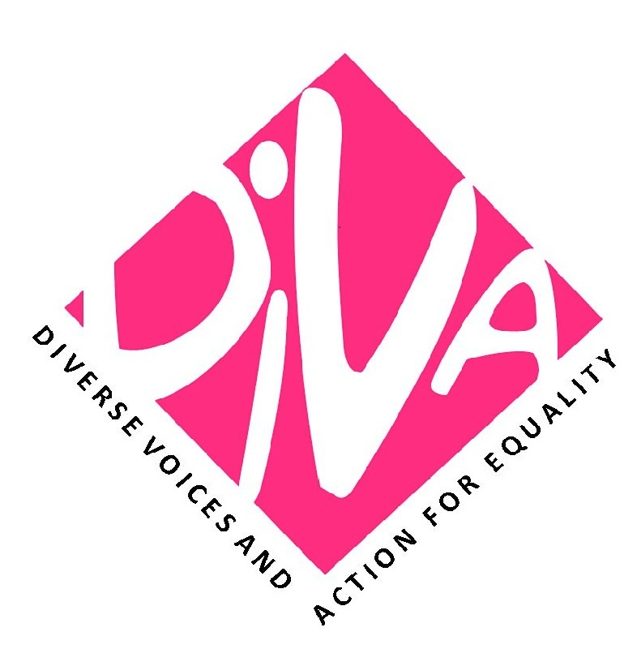
Pacific Partnerships to Strengthen Gender, Climate Change Response and Sustainable Development
9th to 13th June 2014, Nadi (Fiji)
As part of work to advance transformative gender positions throughout national, regional and global sustainable development and Climate Change agendas, an urgent piece of work is to collaboratively build stronger partnerships of civil society and states with a focus on strengthening shared political understandings and strategies. At this conjuncture of Pacific Plan Review process, SIDS, Beijing+20, UNFCCC, SDGS/HLPF, and Post 2015 Development Agenda tracks, there is a timely opportunity to strengthen such partnerships and engagement for implementation of regional and global priorities, with the aim of demonstrating concrete policy results, and also increasing support for women-led civil society groups and national women’s machineries in the Pacific region.
This innovative project brings together national, regional and global women-led CSOs and networks, National Women's Machineries (NWMs) and High level State representatives from NY Missions and Capitals to discuss, strategize and agree on short-term, medium and long-term priorities and political partnerships to advance transformative gender, climate change and DRR positions into the global sustainable development and CC agendas.
The project is jointly developed and co-convened by Secretariat of the Pacific Community, Diverse Voices and Action for Equality and Pacific Youth Council, in partnership with DAWN, The Women’s Major Group on Sustainable Development, Fiji Women’s Rights Movement, WECF, UN Women Multi-Country Office, Dag Hammarskjold Foundation, Global Fund for Women, and Heinrich Boell Foundation with many others providing expertise and financial resources.
In order to maximize outcomes, prior to the meeting participants will be provided with key preparatory resources and asked to contribute their own resources to enable meaningful participation.
For example, CSOs and women-led networks will provide short case studies on gender and climate change/DRR from their work, photos and short YouTube videos. National Women’s Machinery representatives will provide photos, videos and/or information on key best practices, policy gaps and key challenges in integrating gender and climate change/DRR in their work, and government priorities. Pacific negotiators and high level State representatives will contribute to strategic discussions in the networking event of 12 April and the high-level meeting on 13 April, and all participants will receive a substantive package of key regionalised documents on gender, climate and DRR, existing normative Pacific gender agreements and other resources to enable robust engagement at the meeting, and for ongoing use through upcoming CSW and Beijing+20, SIDS, SDGs, UNFCCC and Post 2015 Development Agenda processes.
KEY OBJECTIVES

This process aims to accomplish the following objectives:
- Agree and strategise on urgent and long-term Pacific priorities and political partnerships to advance transformative gender, climate change and DRR positions into the global sustainable development agendas;
- Enhance civil society partnership with Member States to shape Pacific positions in global gender, sustainable development and climate change agendas ;
- Identify how CSOs and NWMs can best support Pacific Missions and capital negotiators to position Pacific urgent and long-term priorities into global advocacy tracks;
- Strengthen mechanisms to monitor the implementation of State-civil society partnerships, promote transparency, accountability and dialogue throughout the global gender, sustainable development and Climate Change agendas

To facilitate the achievement of these objectives, the following framing questions will guide governments, civil society, and regional development agencies that participate to co-construct and analyse the process and content of this initial meeting, build ongoing partnerships, and provide a framework to analyse the findings:
- What policy initiatives related to Gender Equality, Climate Change, DRR and Sustainable Development can be supported through partnerships between States, regional development agencies and civil society?
- What principles and mechanisms will enable civil society to better co-construct the policy design and implementation in a partnership with States?
- What process and technical assistance is necessary to support realization of these partnerships?
- How would meaningful partnerships be assessed? What criteria can be constructed to monitor and evaluate these partnerships?

ACTIVITIES AND EXPECTED OUTCOMES

METHODOLOGY
The first 2 days will be dedicated to strengthening the capacity of Pacific women-led CSOs and networks in advocating for gender equality and women’s human rights in the context of climate change, DRR and sustainable development, and mapping key existing initiatives and partnerships.
The third and fourth days will involve national women’s machineries to further build regional knowledge, strengthen alliances between civil society organisations and NWMs, and strategize on the promotion of gender equality and women’s human rights in the context of climate change, DRR and sustainable development.
High level State representatives including interested Prime Ministers, Presidents, Ambassadors, UNFCCC and P2015DA Negotiators and Mission staff will join the meeting on the evening of the fourth day and for a High Level meeting on Day 5. This will be the opportunity to engage in a high level dialogue, build alliances and strategize for short, medium and long-term partnerships.
By the end of the meeting participants will have:
- Extended non-state and state contacts and networks on G/CC/DRR;
- Common understanding of key Gender/CC/DRR concepts for NGOs and policymakers; Including on Gender equality and women's human rights, and transformative interlinkage approaches to Climate Change and DRR, in the context of sustainable development;
- Set of shared political messages on urgent and slow-onset gender, CC and DRR issues;
- Prioritised set of key action points by CSOs, NWMs and Other Ministries to address key policy challenges and blocks on G/CC/DRR for the Pacific;
- Increased shared knowledge of the ways that high-level Pacific State and non-state groups can champion gender equality, climate change and sustainable development issues into various key upcoming global multilateral negotiations;
- Discussed next steps and any arising concrete political partnerships at national, regional and global levels.

Partners include:

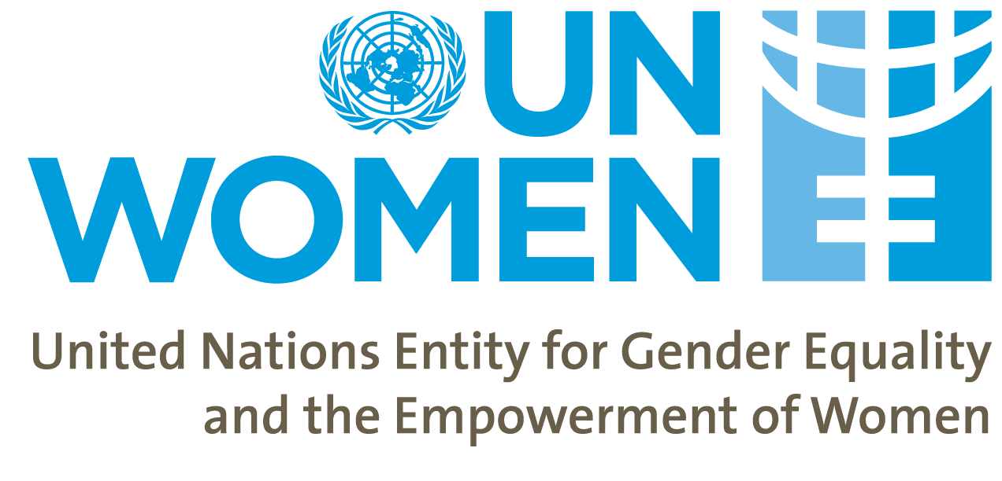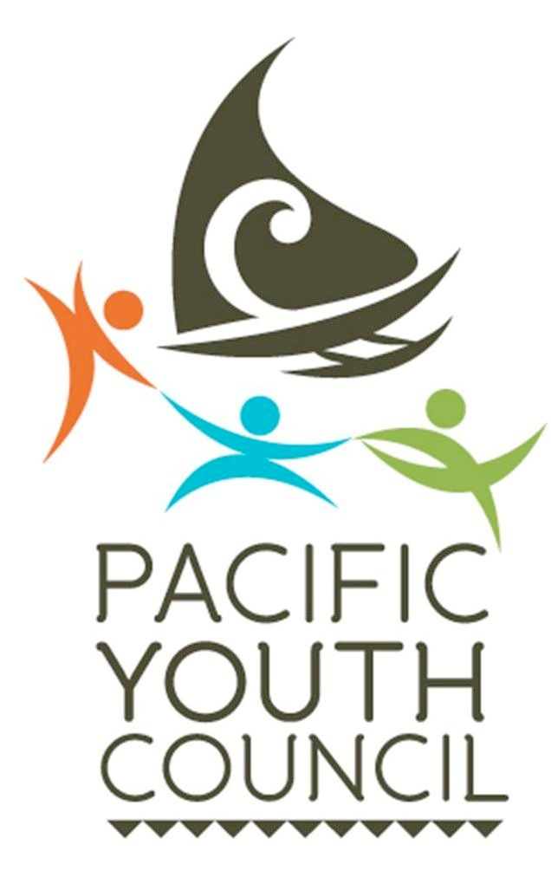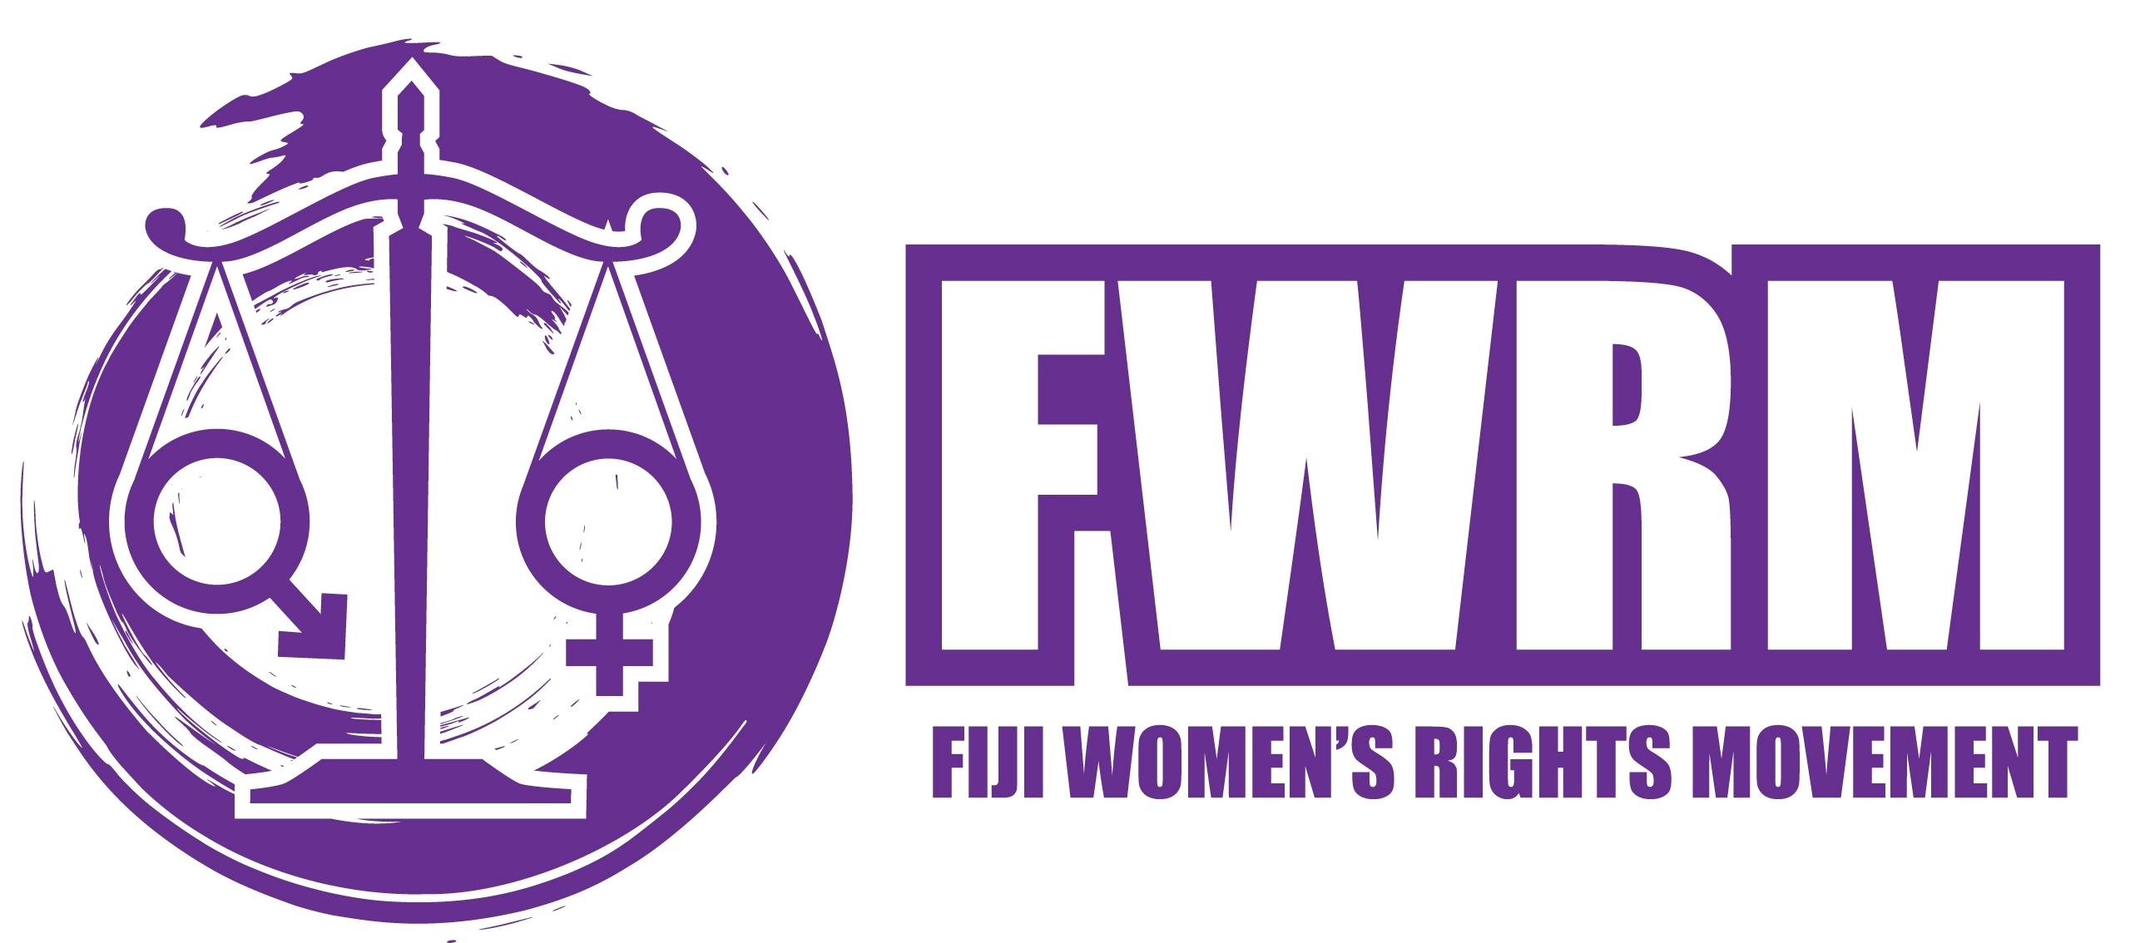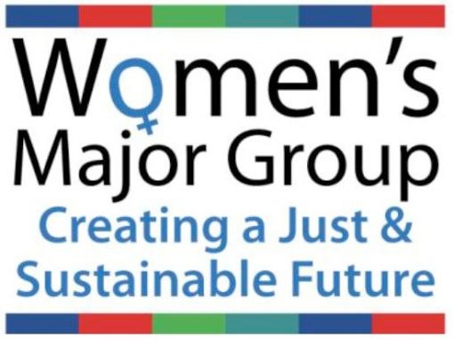

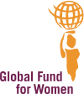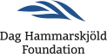

Annex IV. Agenda

DAY ONE: 9 June 2014
OBJECTIVE: ENGAGING WITH CSO'S TO STRATEGICALLY ADVANCE A TRANSFORMATIVE DEVELOPMENT AGENDA INCLUSIVE OF GENDER EQUALITY, CLIMATE JUSTICE AND SUSTAINABLE DEVELOPMENT
PARTICIPANTS: CSO
Schedule | Sessions | Facilitator(s) | Activities
8:00-8:30 | Opening | Brigitte Leduc, SPC,  Noelene Nabulivou- DIVA/DAWN/WMG | -A word of welcome  -Introductions activity Hopes and expectations  -Agreement on learning contract  -Discussion on the agenda
8:30-9:30 | 1. Introduction to Climate Change,  The realities, effects, and impacts on wellbeing and livelihoods | Helene Jacot Des Combes, USP | Short Panel Presentation on climate change
9.30- 10.30 | 2. Gender, Climate Change and disaster risks reduction | Cecilia Aipira, UN Women | Presentation and interactive session
10:30-11:00 | BREAK
11:00 – 12:30 | 3. Gender, Climate Change and Sustainable Development | Brigitte Leduc, SPC  Noelene Nabulivou, DIVA/DAWN/WMG | Presentation and interactive session on gender and climate change
12:30 – 13:00 | 4. Introducing process for mini-statements, and individual work for rest of afternoon | Noelene Nabulivou, DIVA/DAWN/WMG | -Explanation of process, discussion, agreement  -Nominations for drafting committee
13:00-14:00 | LUNCH
14:00-15:00 | Preparation  Gender, climate change, and sustainable development - Interlinkage GEEJ Approach | Noelene Nabulivou, DIVA/DAW N/WMG | Group work towards presentation -TED style (2-3mins only with use of max 5 photos to illustrate your presentation-Room discussion for 10 min while facilitator B writes up key points on wall under Gender/Social/ Economic/Environmental  -Problems addressed  -Strategies used  -Lessons Learnt
15:00-15:30 | Presentation  Gender, climate change, and sustainable development - Interlinkage GEEJ Approach | Noelene Nabulivou, DIVA/DAWN/WMG | Presentations by group -TED style (2-3mins only with use of max 5 photos to illustrate your presentation-Room discussion for 10 min while facilitator B writes up key points on wall under Gender/Social/Economic/ Environmental  Problems addressed  Strategies used  Lessons Learnt
15:30-15:45 | BREAK
15:45-16:15 | Presentation from the rapporteur + key messages | Noelene Nabulivou, DIVA/DAWN/WMG  Kathryn Tobin, Dag Hammarskjöld Foundation | Presentation and plenary
16:15 – 17:30 | Preparation of the mini statements | Noelene Nabulivou, DIVA/DAWN/WMG  Brigitte Leduc,SPC  Anita Nayar,Dag Hammarskjöld Foundation | Individual work
17:30:00 | Drafting committee meeting for CSO Outcome Statement, |  | While individual mini-statements are drafted, drafting committee meets and proposes 6-8 key messages and commitments toward promotion of gender equality and climate justice in the national, regional and global development and environmental agendas.  Drafting committee share draft list of proposed and priorities key messages with the room at 1700, then final discussions for Day 1.
EVENING �ALL WORK ON MINI-STATEMENTS, IN READINESS FOR DAY 2. ALL ARE REQUIRED TO ARRIVE AT ROOM IN THE MORNING WITH DRAFT MINI-STATEMENT INCORPORATING AT LEAST 3 OF THE KEY MESSAGES.
DAY TWO: 10 June 2014
OBJECTIVE: STRENGTHENING CSO ADVOCACY POSITIONS IN COMMUNICATIONS WITH STATES, UN AGENCIES, REGIONAL ORGANIZATIONS, AND EACH OTHER.
PARTICIPANTS: CSO
Schedule | Sessions | Facilitator(s) | Activities
8:30-10:30 | 5. Gender, Climate Change and Sustainable Development: Feminist Interlinkage and Intersectional analysis | Noelene Nabulivou, DIVA/DAWN/WMG | Interactive room-based activities  6 hats methodology – fish bowl
10:30-11:00 | BREAK
11:00-13:00 | 6. Smart and strong analysis, advocacy and movement building | Cherelle Jackson, ILO | Radio-show format :  (Karaingi to talk on resource-poor mobilising)  -Brianna Fruen and Kelvin Anthony (how movement change over time 350)  -Matelita Houa: How to work with government while building youth climate change initiatives in a small islands  -Virisila Buadromo (graduated position)  -Noelene Nabulivou (CSOs under government delegations)
13:00-14:00 | LUNCH
14:00-15:00 | 7. Mapping CSO roles in advocacy processes-local, national, international | Kathryn Tobin | -Presentation  -Rapporteur and room discussion
15.00-15.30 | 8. Bodies and communication | Shirley Tagi, DIVA | Presentation  Exercises
15:30-16:00 | Break
16:00-17:00 | 9. Mock presentations of mini-statements | Noelene Nabulivou, DIVA/DAWN/WMG | Practice session  Panel – Virisila, Brigitte, Liane, Sangeeta
17:00:00 | Drafting committee meeting for CSO Outcome Statement, SIDSs frame |  | Reminder of framework:  -Ideas  -Process  -Engagement
DAY THREE: 11 June 2014
OBJECTIVE: CSOS, NWMS AND OTHER STATES ACTORS BUILDING ALLIANCES TO STRATEGICALLY ADVANCE A TRANSFORMATIVE DEVELOPMENT AGENDA INCLUSIVE OF GENDER EQUALITY, CLIMATE CHANGE AND SUSTAINABLE DEVELOPMENT
PARTICIPANTS: CSO & NWM & Other states’ actors
Schedule | Sessions | Facilitator(s) | Activities
8:30-9:00 | Opening | Brigitte Leduc SPC  Noelene Nabulivou, DIVA/DAWN/WMG | Activity for getting to know each other - Partnership  Nominations for additional NWMs reps. in drafting committee
9:00-10:30 | 10. Gender, climate change, and sustainable development: Initiating Strategic Dialogues | Brigitte Leduc, SPC  Joanne Lee Kunatuba, SPC | 1. 2 min. story-telling by NWMs on:  - Disasters  - Health  - Food security  - Water security  - Ocean  - Economic  2. Linking with key messages drafted by CSOs  3. Plenary  - What are the opportunities to move this forward?  - What can be the triggers and enabling factors?  - What can be easily moved and which is harder to move at this time and why?
10.30-11.00 | BREAK
11:00-12:00 | CONT. Gender, climate change, and sustainable development | Brigitte Leduc, SPC  Joanne Kunatuba, SPC | Plenary
12:00-13:00 | 11. SIDS – Barbados – programme of action and Mauritius Strategy of implementation | Brigitte Leduc, SPC | Presentation and discussion  Cherelle Jackson  Noelene Nabulivou  Anita Nayar
13:00-14:00 | LUNCH
14:00-15:30 | 12. More than the money: Loss and damage, climate finance and more? | Marita Manley, GIZ | Panel: (TO BE RECORDED)  Sharmind Neelormi  Liane Schalatek  Aaron Atteridge
15:30-16:00 | BREAK
16:00-17:00 | 13. Tips and tricks for effective advocacy and lobbying | Brigitte Leduc, SPC | Anne Kautu Noelene Nabulivou  Virisila Buadromo  Shirley Tagi
17:00:00 | Drafting committee meeting for CSO Outcome Statement, SIDSs frame |  | Refine key message with NWMs  Reminder of framework:  Ideas  Process  Engagement
DAY FOUR: 12 June 2014
OBJECTIVE: EFFECTIVE PARTNERSHIPS FOR AN INTEGRATED APPROACH TO PROMOTE GENDER EQUALITY, WOMEN’S HUMAN RIGHTS, CLIMATE JUSTICE AND SUSTAINABLE DEVELOPMENT
PARTICIPANTS: CSO & NWM & Other states’ actors
 | Sessions | Facilitator(s) | Activities
8.30-10:30 | 14. The human rights normative framework for gender equality and women’s human rights | Noelene Nabulivou, DIVA/DAWN/WMG | Brigitte Leduc, SPC Virisila Buadromo, FWRM  Seema Naidu, PIFS, Dr Nese Conway- Ministry of Health, Tuvalu
10:30-11:00 | Break
11:00-13:00 | 15. Multilateral processes of gender, climate change and sustainable development | Kairangi Samuela, Puanaga Tauturu | Panel (talk show type)  1.Resina Katafono, PIFS 2. Noelene Nabulivou: WMG  3.Helen Beck on the role of Solomon Islands in UN Women  4.Sabine Bock, UNFCCC
13:00-14:00 | Lunch
14:00-15:30 | Drafting committee meeting |  | Finalise  Ideas  Process  Engagement
15:30-16:00 | Break
16.00-17.00 | Maximizing advocacy opportunities: gender equality, climate change and sustainable development | Noelene Nabulivou, DIVA/DAWN/WMG  Brigitte Leduc, SPC | Group Work: What they can practically do?
DAY FOUR: 12 June 2014
Pacific Dinner Dialogue on gender equality, climate change, sustainable development and post 2015 development agenda
18:30-18:45 | Welcome by the MC | PERFORMANCE  Camari Serau, Poem  Shirley Tagi, Song
18:45-19:00 | Opening REMARK: Fekita Utoikamanu, Deputy Director General, SPC
19:00-19:30 | Key note speakers:  Noelene Nabulivou, Women’s Major Group on Sustainable Development, Women’s Major Group Perspective ;  DAISY ALIK-MOMOTARO  HE Honorable Enele Sopoaga, Prime Minister of Tuvalu, Moving from Commitment to Action
19:30-19:45 | Presentation of draft outcome document by CSO reps and joint work of NWMs and CSOs
20:00:00 | Prayer – Ecumenical – Pacific Conference of Churches; TARUSILA BRADBURGH
DAY FIVE: 13 June 2014
OBJECTIVE: BUILDING ALLIANCES TO STRENTHEN PACIFIC LEADERSHIP FOR A TRANSFORMATIVE GLOBAL DEVELOPMENT AGENDA PROMOTING GENDER EQUALITY, CLIMATE JUSTICE, AND SUSTAINABLE DEVELOPMENT
High Level Dialogue
Schedule | Sessions | Facilitator(s) | Activities
8.30-9.00 | Meeting Commencement, Chair introductions |  | Fekita Utoikamanu, Deputy Director General, SPC  HE Honorable Enele Sopoaga, Prime Minister of Tuvalu
9.00-10.30 | Interconnectivity of gender equality, climate justice and sustainable development | Claire Slatter, DAWN/USP | Interconnectivity of all processes – from global, regional, local and back
10:30-11.00 | Break
11.00-12.15 | The Ideas - ‘Gains, Challenges and Possibilities: Visions of Pacific Gender, Climate and Development Justice’ | Noelene Nabulivou,DIVA/DAWN/WMG | Four TED-type keynote presentations by women’s CSOs, NWM and States  Daisy Alik Momotaro – RMI  Savina, Daula'asi, PDF, Solomon Islands  Virisila Buadromo, FWMR Fiji  Honorable Charmaine Scotty - Nauru
12.15-13.00 | Discussion
13:00-14:00 | Lunch
14.00-15.30 | The Processes - ‘Global processes: Gender, Climate change and Sustainable Development’ | Brigitte Leduc, SPC | Esrom Vano– Vanuatu Dr Nese Conway, Ministry of Health. Tuvalu  Elzira Sangynbeava, UNWomen  Helen Beck – Solomon Islands N.Y Mission
15.30-15.45 | Break
15.45-16.45 | Championing Change - ‘How will you personally champion issues of gender, climate change and sustainable development and motivate others?’ | Claire Slatter, DAWN,USP | Christina Ora, Solomon Islands Kairangi Samuela, Punaga Tauturu Inc -Cook Islands  Cristelle Pratt, Deputy Secretary General at Pacific Islands Forum Secretariat  Honorable Tangariki Reete, Minister for Women, Youth, and Social Affairs of Kiribati – TBC  HE Honorable Enele Sopoaga, Prime Minister of Tuvalu
16.45-17.30 | CLOSING REMARKS and adoption of 2-pages outcomes document

Annex V. Participants’ List

NAME | COUNTRY | TITLE | ORGANISATION
VIRISILA BUADROMO | FIJI | EXECUTIVE DIRECTOR | FIJI WOMEN’S RIGHTS MOVEMENT
KELVIN ANTHONY | FIJI | GLOBAL SIDS YOUTH FOCAL POINT | SIDS YOUTH NETWORK / 350.ORG
SAVINA DAULA'ASI | SOLOMON ISLANDS | PRESIDENT/MEMBER | SOLOMON ISLANDS DISABILITY ORGANISATION / PACIFIC DISABILITIES FORUM
MELINA NONGEBATU | SOLOMON ISLANDS | AIDE | PACIFIC DISABILITIES FORUM
ADI VASULEVU CHUTE | FIJI | CLIMATE CHANGE ACTIVIST | TRANSCEND OCEANIA FIJI / FEMLINK
BRIANNA FRUEN | SAMOA | CLIMATE CHANGE ACTIVIST | SIDS YOUTH NETWORK
KATHRYN RELANG | RMI | EXECUTIVE DIRECTOR | WOMEN UNITED TOGETHER MARSHALL ISLANDS (WUTMI)
ANN KITALONG | PALAU | BIOLOGIST/ENVIRONMENTALIST | THE ENVIRONMENT INC
MATELITA HOUA | TONGA | PROJECT OFFICER | TONGAN YOUTH CONGRESS / 350.ORG
IMOGEN INGRAM | COOK ISLANDS | ENVIRONMENTAL ACTIVIST | ISLAND SUSTAINABILITY ALLIANCE / THE INTERNATIONAL NETWORK FOR THE ELIMINATION OF POPS
KAIRANGI SAMUELA | COOK ISLANDS | MANAGER | PUNAGA TAUTURU INC
ANNE HUBERT | NAURU | PRESIDENT/COORDINATOR | NAURU YOUTH COUNCIL
CHRISTINA ORA | SOLOMON ISLANDS | CLIMATE CHANGE ACTIVIST | HONIARA CITY YOUTH COUNCIL/SOLS YOUNG WOMEN'S PARLIMENTARY GROUP
CHERELLE JACKSON | SAMOA | SIDS COORDINATOR | INTERNATIONAL LABOUR ORGANISATION
MOIA TETOA | KIRIBATI | PRESIDENT | AIA MWAEA AINEN
MILIKINI FAILAUTUSI | TUVALU | COORDINATOR | TUVALU YOUTH COUNCIL
ERANA ALIKLIK | NAURU | COORDINATOR | NAURU WASTE REHABILIATION CORPORATION
NOELENE NABULIVOU | FIJI | SIDS FOCAL POINT-WMG, ADVISER-DIVA FOR EQUALITY, DAWN ASSOCIATE | WOMEN’S MAJOR GROUP / DIVA FOR EQUALITY / DAWN
BRIGITTE LEDUC | NEW CALEDONIA | GENDER ADVISER | SECRETARIAT OF THE PACIFIC COMMUNITY
KATHRYN TOBIN | USA | RESEARCHER | DAG HAMMARSKJÖLD FOUNDATION
TARUSILA BRADBURG | FIJI | COORDINATOR | PACIFIC YOUTH COUNCIL
SHIRLEY TAGI | FIJI | COORDINATOR | DIVA FOR EQUALITY
SHARMIND NEELORMI | BANGLADESH | ASSOCIATE PROFESSOR | JAHANGIRNAGAR UNIVERSITY, SAVAR, BANGLADESH
MEREONI T. ROBINSON | FIJI | PROJECT ASSISTANT | SECRETARIAT OF THE PACIFIC COMMUNITY
JOANNE LEE | FIJI | GENDER OFFICER | SECRETARIAT OF THE PACIFIC COMMUNITY
MARITA MANLEY | FIJI | TECHINCAL ADVISER, CLIMATE CHANGE | SECRETARIAT OF THE PACIFIC COMMUNITY
CECILIA AIPIRA | FIJI | REGIONAL GENDER DRR AND CC ADVISER | UN WOMEN PACIFIC
SANGEETA CHOWDHRY | USA | PROGRAMME DIRECTOR, ASIA PACIFIC | GLOBAL FUND FOR WOMEN
LIANE SCHALATEK | USA | ASSOCIATE DIRECTOR | HEINRICH BÖLL FOUNDATION NORTH AMERICA
SABINE BOCK | GERMANY | DIRECTOR/COORDINATOR OF ENERGY AND CLIMATE CHANGE | WOMEN IN EUROPE FOR A COMMON FUTURE
SEEMA NAIDU | FIJI | GENDER OFFICER | PACUFIC ISLANDS FORUM SECRETARIAT
CAMARI SERAU | FIJI | MANAGEMENT COLLECTIVE | DIVA FOR EQUALITY
VIVA TATAWAQA | FIJI | MANAGEMENT COLLECTIVE | DIVA FOR EQUALITY
HELENE DES COMBES | FIJI | CLIMATE CHANGE LECTURER | PACIFIC CENTRE FOR ENVIRONMENT AND SUSTAINABLE DEVELOPMENT, UNIVERSITY OF THE SOUTH PACIFIC
NICOLETTE GOULDING | FIJI | ASSISTANT M&E OFFICER | SECRETARIAT OF THE PACIFIC COMMUNITY
KIM SACHS | FIJI | INTERN | PACIFIC YOUTH COUNCIL
RESINA KATAFONO | FIJI | MDG'S REGIONAL ADVISER | PACIFIC ISLANDS FORUM SECRETARIAT
HANA ELIAS | FIJI | INDEPENDENT MEDIA INTERN | INDEPENDENT
ESROM VANO | VANUATU | CLIMATE CHANGE & DRM FOCAL POINT | DEPARTMENT OF WOMEN
NELLY KERE | SOLOMON ISLANDS | SOLOMON ISLANDS NATIONAL CLIMATE CHANGE COORDINATOR | MINISTRY OF ENVIRONMENT, CLIMATE CHANGE, DISASTER MANAGEMENT & METEOROLOGY
POLOTU FAKAFANUA-PAUNGA | TONGA | DIRECTOR OF WOMEN | DEPARTMENT OF WOMEN
ASITA MOLOTII | TUVALU | DIRECTOR OF WOMEN | DEPARTMENT OF WOMEN
DAISY ALIK-MOMOTARO | RMI | PERMANENT SECRETARY | MINISTRY OF INTERNAL AFFAIRS
RAIJIELI MAWA | FIJI | PRINCIPAL OFFICER | MINISTRY OF WOMEN
LOUISA APELU | SAMOA | ASSISTANT CEO | MINISTRY OF WOMEN, COMMUNITY & SOCIAL DEVELOPMENT
ANNE KAUTU | KIRIBATI | DIRECTOR OF WOMEN'S AFFAIRS | MINISTRY OF WOMEN
RUTH POKURA | COOK ISLANDS | DIRECTOR OF GENDER DIVISION | MINISTRY OF INTERNAL AFFAIRS
HONORABLE MINISTER TANAGARIKI REETE | KIRIBATI | MINISTER | MINISTRY OF WOMEN YOUTH AND SOCIAL AFFAIRS
HELEN BECK | SOLOMON ISLANDS | COUNSEL | PERMANENT MISSION TO THE UNITED NATIONS
HONORABLE CHARMAINE SCOTTY | NAURU | MINISTER | MINISTRY OF HOME AFFAIRS
AARON ATTERIDGE | FIJI | CLIMATE CHANGE ADVISER | SECRETARIAT OF THE PACIFIC COMMUNITY
ANDIE FONG TOY | FIJI | DEPUTY SECRETARY GENERAL | PACIFIC ISLANDS FORUM SECRETARIAT
CLAIRE SLATTER | FIJI | LECTURER, DAWN CHAIR/PANG BOARD MEMBER | UNIVERSITY OF THE SOUTH PACIFIC, DAWN, PACIFIC NETWORK ON GLOBALIZATION (PANG)
MAKERETA KOMAI | FIJI | HEAD, PACNEWS | PACNEWS
DRUE SLATTER | FIJI | JOURNALIST | MAI LIFE
FEKITA 'UTOIKAMANU | FIJI | DEPUTY DIRECTOR- GENERAL, EDUCATION, TRAINING AND HUMAN DEVELOPMENT DIVISION | SECRETARIAT OF THE PACIFIC COMMUNITY
MIIRE RAIETA AWIRA | KIRIBATI | PERMANENT SECRETARY | MINISTRY OF WOMEN YOUTH AND SOCIAL AFFAIRS
DAVID HESAIE | FIJI | NON STATE ACTORS OFFICER | PACIFIC ISLANDS FORUM SECRETARIAT
ELLIE VAN BAAREN | FIJI | REGIONAL COMMUNICATIONS AND MEDIA SPECIALIST | UN WOMEN
EMELE DUITUTURAGA | FIJI | EXECUTIVE DIRECTOR | PACIFIC ISLANDS ASSOCIATION OF NON-GOVERNMENTAL ORGANISATIONS (PIANGO)
KATE MORIOKA | JAPAN | CONSULTANT | SECRETARIAT OF THE PACIFIC COMMUNITY / Gesellschaft für Internationale Zusammenarbeit
RANJILA SINGH | FIJI | RESEARCHER | UNIVERSITY OF THE SOUTH PACIFIC

Annex VI. Background Documents and Conference Resources

Each participant was provided with a USB drive with a large amount of resources as background information for the conference. These resources included:

Climate and Finance
- Gender-Equitable Financing for Sustainable Development – Liane Schalatek (paper)
- Climate Finance Fundamentals – briefing series by Heinrich Böll and ODI
- Normative Framework for Public Climate Change Finance
- Evolving Global Climate Finance Architecture
- Thematic Briefing – Adaptation Finance
- Thematic Briefing – Mitigation Finance
- Thematic Briefing – REDD+ Finance
- Regional Briefing – Latin America
- Regional Briefing – Sub-Saharan Africa
- Regional Briefing – Asia-Pacific
- Regional Briefing – MENA
- Gender and Climate Change
- The Green Climate Fund

Climate and Fisheries
- Climate Change: Implications for Fisheries & Aquaculture - Fifth Assessment Report, Intergovernmental Panel on Climate Change

Declarations and Outcomes
- Beijing+20 Calendar
- Feminists Post-2015 Declaration
- The Future Asia-Pacific Women Want
- Ministerial Communique
- Pacific Young Women’s Leadership Alliance – Outcome Statement
- Outcomes of the 12th Triennial Conference of Pacific Women
- SIDS:
- Barbados Outcome Statement
- Barbados Programme of Action
- Mauritius Strategy
- Statement for SIDS PrepCom 1, Women’s Major Group
- Statement for SIDS Interregional Meeting, Women’s Major Group
- Statement to Pacific SIDS July 2013, Women’s Major Group
- Statement to Pacific SIDS July 2013 2, Women’s Major Group
- Response to the SIDS Zero Draft, Women’s Major Group
- UN-NGLS Interview with Noelene Nabulivou

Pacific Priorities
- Analysis of Pacific Positions in the Open Working Group Focus Areas Document http://bit.ly/1pltggK
- Analysis of Pacific Positions in the HLPF Regional Preparatory Process http://bit.ly/RUv3gm
- Analysis of Pacific Positions on Priority Issues http://bit.ly/1q4RIm5

Training of Trainers Advocates Resources

Gender and DRR
- Guide to developing national action plans - A Tool for Mainstreaming Disaster Risk Management Based on experiences from selected Pacific Island Countries, Pacific Disaster Risk Partnership Network
- Guidelines for Gender-based Violence Interventions in Humanitarian Settings - Focusing on Prevention of and Response to Sexual Violence in Emergencies, IASC Task Force on Gender in Humanitarian Assistance
- Gender Perspective: Working Together for Disaster Risk Reduction - Good Practices and Lessons Learned, UNISDR
- Making Disaster Risk Reduction Gender-Sensitive – Policy and Practical Guidelines, UNISDR, UNDP, IUCN
- Building gendered approaches to adaptation in the Pacific, Gender and Development
- A Little Gender Handbook for Emergencies, Oxfam GB
- Preventing Crisis, Enabling Recovery: A Review of UNDP’s Work in Conflict and Disaster-Affected Countries: 2012, UNDP
- Gender Sensitive Disaster Management – A Toolkit for Practitioners, Oxfam America and NANBAN Trust

Gender and Energy
- Gender and Energy for Sustainable Development – A Toolkit and Resource Guide, UNDP
- Gender Mainstreaming in Energy Sector – Presentation, ENERGIA
- Pacific Energy and Gender Network Regional Strategic Planning Workshop, SOPAC and PEG
- The Gender Face of Energy - A Training Manual Adapted to the Pacific Context from the ENERGIA Commissioned Training Manual: Introduction, Module 1, Module 2, SOPAC, ENERGIA, and CTA

Gender and Food Security
- A climate for change: Understanding women’s vulnerability and adaptive capacity to climate change from ActionAid’s rights-based approach – case studies from Papua New Guinea and Solomon Islands, ActionAid
- Gender analysis in macroeconomic and agricultural sector policies and programmes, FAO’s SEAGA
- Gender and climate change: mapping the linkages: A scoping study on knowledge and gaps, BRIDGE/IDS, DFID
- Gender dimensions of agricultural and rural employment: Differentiated pathways out of poverty - Status, trends and gaps, IFAD, FAO, ILO
- Gender Links in Agriculture and Climate Change, WIA-ISIS
- Gender: The Missing Component of the Response to Climate Change, FAO
- Passport to Mainstreaming Gender in Water Programmes - Key questions for interventions in the agricultural sector, GEWAMED, GWA, FAO
- People-Centred Climate Change Adaptation: Integrating Gender Issues, FAO
- Training Guide - Gender and Climate Change Research in Agriculture and Food Security for Rural Development, CGIAR, FAO

Gender and Water
- Women and Water – UN DAW, UNDESA
- Gender Mainstreaming in Agricultural Water Management
- Gender mainstreaming - An essential component of sustainable water management, Global Water Partnership
- The Gender and Water Development Report 2003: Gender Perspectives on Policies in the Water Sector, Gender and Water Alliance
- Advocacy Manual for Gender & Water Ambassadors, Gender and Water Alliance
- Gender, Water and Climate Change – Gender and Water Alliance
- Intermediate-Level Handbook, FAO’s SEAGA
- Macro-Level Handbook, FAO’s SEAGA
- Why Gender Matters - A tutorial for water managers, Cap-Net, Gender and Water Alliance, UNDP
- Women and Water: An Ethical Issue, UNESCO and World Commission on the Ethics of Scientific Knowledge and Technology

Gender Manuals
  - What Works for Women: Proven approaches for empowering women smallholders and achieving food security, ActionAid International, CARE, Christian Aid, Concern Worldwide, Find Your Feet, Oxfam, Practical Action, Save the Children, Self Help Africa
  - Climate Change and Gender Justice, Practical Action and Oxfam
  - Climate Change Connections: Gender, Population and Climate Change, UNFPA and WEDO
  - Disaster Risk Reduction & Climate Change Adaptation in the Pacific: An Institutional and Policy Analysis, UNISDR, UNDP, and GFDRR
  - Gender Into Climate Policy: Toolkit for Climate Experts and Decision-Makers, GenderCC – Women for Climate Justice
  - Gender and Climate Change, IUCN
  - Resource Guide on Gender and Climate Change, UNDP
  - Training Manual on Gender and Climate Change, IUCN, UNDP, GCCA
  - Gender, Climate Change and Community-Based Adaptation: A Guidebook for Designing and Implementing Gender-Sensitive Community-Based Adaptation Programmes and Projects, UNDP
  - Gender and Climate Change Capacity Development Series, Asia and the Pacific: Gender and Adaptation – Training Module, UNDP
  - Women at the Frontline of Climate Change: Gender Risks and Hopes, UNEP, ICIMOD, CICERO
  - Changing the Climate: Why Women’s Perspectives Matter, WEDO
  - Women, Gender Equality and Climate Change – Fact Sheet, UN WomenWatch

Pacific Climate Change Science Program - Brochures
- Introduction
- Cook Islands
- East Timor
- Fiji
- Federated States of Micronesia
- Kiribati
- Marshall Islands
- Nauru
- Niue
- Palau
- Papua New Guinea
- Samoa
- Solomon Islands
- Tuvalu
- Vanuatu
- Tonga

Pacific Gender Resources
  - Integrating Gender in Disaster Management in Small Island Developing States: A Guide, UNDP
  - The gendered dimensions of disaster risk management and adaptation to climate change - Stories from the Pacific, AusAid and UNDP
  - Tuvalu Time-Use Poster, NAPA, AusAid, GEF, UNDP
  - Gender assessment – Tuvalu NAPA 1/+ Project, GEF, AusAid, UNDP, Tuvalu

Strategy for Climate and Disaster Resilient Development in the Pacific (SRDP)
  - Draft Strategy, PIFS
  - Response ANON­7CF1­WSDG­6, SPC, PIFS, UNISDR, SPREP, UNDP, USP
  - Consolidated Reply - Climate Change & Development (CCD) Community of the Pacific - Solution Exchange
  - Extracts, with references to Gender
  - Workshop: Strategy for Climate and Disaster Resilient Development in the Pacific – Providing feedback from a gender perspective

UNDP & GCCA Asia-Pacific Briefs
  - Gender and Climate Change Linkages
  - Gender Adaptation Training Manual
  - Gender Adaptation Policy Brief
  - Gender and Climate Finance Training Manual
  - Gender and Climate Finance Policy Brief
  - Gender and DRR Training Manual
  - Gender and DRR Policy Brief
  - Gender and Energy

Vulnerability Assessment Tools
- Understanding Vulnerability to Climate Change, CARE
- The Ecosystem Approach to Coastal Fisheries and Aquaculture in Pacific Island Countries and Territories, SPC and The Nature Conservancy
- Vulnerability and Capacity Assessment – Lessons Learned and Recommendations, International Federation of Red Cross and Red Crescent Societies
- Vulnerability and Capacity Assessment – An International Federation Guide, International Federation of Red Cross and Red Crescent Societies
- What is VCA? An introduction to vulnerability and capacity assessment, International Federation of Red Cross and Red Crescent Societies
- How to do a VCA, International Federation of Red Cross and Red Crescent Societies
- VCA toolbox with reference sheets, International Federation of Red Cross and Red Crescent Societies
- PACE-SD Guidebook: Participatory Vulnerability and Adaptation Assessment, USP
- CV&A: A Guide to Community Vulnerability and Adaptation Assessment and Action, SPREP

Briefs: Miscellaneous
  - Women and Climate Change, Climate and Development Knowledge Network (CDKN)
  - Manila Declaration for Global Action on Gender in Climate Change and Disaster Risk Reduction, Participants of Third Global Congress of Women in Politics and Governance

Other Documents
- Gaps and Needs Analysis towards the development of a Climate Change Policy Framework – SPC, GCCA, EU, BMZ, GIZ
- Consolidated Reply Query: Gender and Climate Change, Climate Change & Development (CCD) Community of the Pacific - Solution Exchange
- Disaster response and climate change in the Pacific, NCCARF and University of Technology Sydney
- Vulnerability of Tropical Pacific Fisheries and Aquaculture to Climate Change, SPC
- UNFCCC COP 18 – Gender Submission, Vanuatu

Youth Folder

Articles
- Advancing Youth Civic Engagement and Human Rights with Young Women and Young Men, UN Habitat
- No Accident: Resilience and the inequality of risk, Oxfam
- Consolidated Reply Query: Engaging Youth in Agriculture and Forestry, Climate Change & Development (CCD) Community, of the Pacific Solution Exchange
- Consolidated Reply Query: Backyard Farming for Urban Women in Low Lying Areas, Climate Change & Development (CCD) Community, of the Pacific Solution Exchange
- Article, Shirley Laban, Vanuatu NGO Climate Adaptation Program Manager, Oxfam
- Report on the meeting on available tools for the use of indigenous and traditional knowledge and practices for adaptation, needs of local and indigenous communities and the application of gender-sensitive approaches and tools for adaptation, UNFCCC
- Looking Beyond 2014 into Post-2015, Youth Coalition
- Youth Employment Advocacy! Initiative: A guide for youth advocacy in Pacific Island Countries, Pacific Youth Council
- Youth 21: Building an Architecture for Youth Engagement in the UN System, UN Habitat

Outcome Documents
- Statement to SIDS Inter-Regional Preparatory Meeting, Major Group of Children and Youth
- Statement to the Asia Pacific Forum on Sustainable Development, Major Group of Children and Youth
- Outcome of SIDS Inter-regional preparatory meeting
- 2013 Pacific Regional MDGs Report, PIFS
- Pacific Civil Society Statement, Joint PIFS-SPC Regional CSO Dialogue on Conflict, Peace & Security
- Outcome Statement, DRM Youth Forum
- Meeting Statement, Sixth Session of the Pacific Platform for Disaster Risk Management
- Outcome Statement, Pacific Young Women’s Leadership Alliance
- Youth as Partners in Sustainable Small Island Development, SIDS Youth Outcome Document
- From the Colombo Declaration on Youth to the World Conference on DRR – Youth Seal DRR on the Post-2015 Development Agenda

Annex VII. Videos of the Conference

Introduction to Climate Change as a Gender Issue (4 min)
https://www.youtube.com/watch?v=VkpQVgURVEU

Participants introducing themselves and their expectations for the meeting (7 min) https://www.youtube.com/watch?v=5qXrOG59zPU#t=408

What brought you to the meeting? (3 min)
https://www.youtube.com/watch?v=nuABoaz6Kuw

Opening Statement (Day 3) by Christina Ora, youth activist from Solomon Islands (4 min)
https://www.youtube.com/watch?v=0UZmhu15cDg

Summary of Kathryn Tobin’s presentation (5 min)
https://www.youtube.com/watch?v=d63-8da7TvE

Noelene Nabulivou introduces De Bono’s Strategy of Six Thinking Hats (3 min)
https://www.youtube.com/watch?v=FBd3UGNYtc4

How to Say It: Reaching Shared Communications Strategies (7 min)
https://www.youtube.com/watch?v=ULy-rTQXpRA

Annex VIII. PPGCCSD on Social Media

Facebook: https://www.facebook.com/PPGCCSD
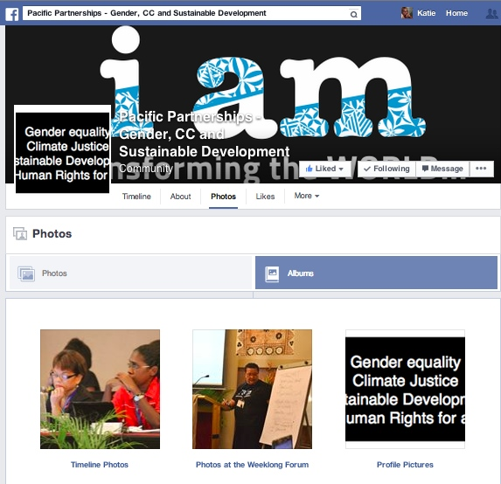

Twitter: https://twitter.com/PacificSGCCSD
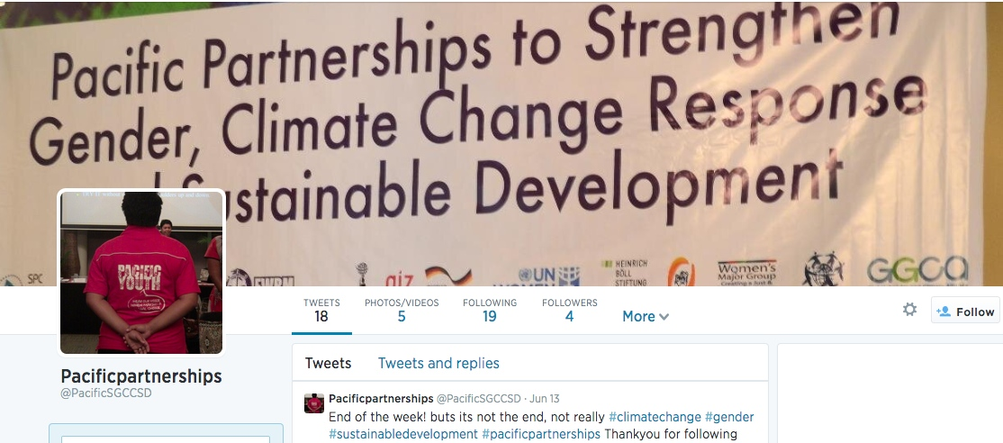

YouTube: https://www.youtube.com/channel/UC8boO82cButp2tNqIOHHmQA
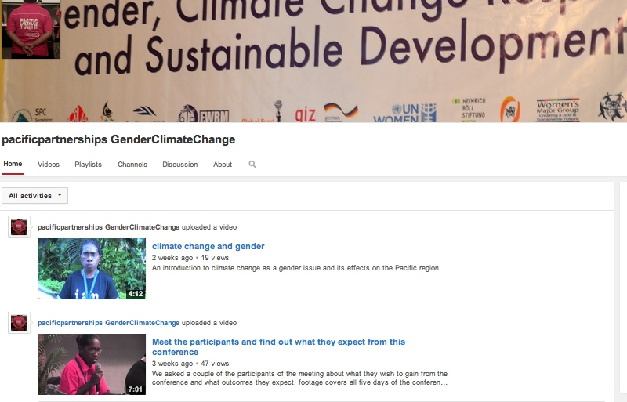

Annex IX. Key Themes Raised at the Conference

Day 1

Foundational Ideas/Context:
- Women and men have different roles, capacities and constraints, power, and therefore different needs, sensitivity to climate change impact. Women tend to be more vulnerable to natural disasters. Women have the skills to contribute to efforts in disaster risk reduction and resilience to climate change. Women are not only victims of disaster but as service deliverers (nurses, teachers) as well, dealing with their own trauma and that of others
- Climate change adaptation is everyone’s business; everyone has skills and knowledge to contribute. Climate change and disaster risk reduction are linked and must be addressed together, including in terms of their gendered and social impacts
- Unique situation of PSIDS at fulcrum of climate change impacts, sea level rise, extreme weather events, ocean acidification as a result of continued burning of fossil fuels by developed nations
- URGENCY of the issue. Existential nature of these problems. Must be addressed urgently. Increasing intensity, number of disasters, amount of people affected.

Things we need to do:
- Need funding to do awareness-raising with women. Direct funding towards learning from local knowledge and community-based resilience, build upon knowledge with new technologies
- Need data, disaggregated by sex and age, for evidence-based advocacy. Collect data, analyze, show evidence of why social impacts important in climate change and DRR. Gender analysis of statistics. Need economic analysis of gendered impacts of loss and damage; social cost analysis as a credible modality we can use
- Learn from existing knowledge in the Pacific, especially of women and youth, especially of areas most affected by climate change and extreme weather events; build capacity of women and youth as agents of change. Include all forms of traditional and heterodox knowledge
- So many development processes ongoing – concerns and aspirations of Pacific women need to be reflected - women should not be left out, need to be included. Women should be the focus of any working around climate change as they are in a vulnerable group, along with persons with disabilities – nothing about us without us kind of approach. Ensure rights of persons with disabilities, through an inclusive manner and approach, to make sure persons with disabilities will not be left out.
- Support women in decision-making – allies towards interlinkage approach: climate change + gender and sustainable development
- Ensure adequate channels of information sharing
- Improve coherence in government responses to disasters, strategies that take into account gendered differences in impact
- Need to balance social and environmental concerns in DRR
- Partnership with government civil society regional organizations, private sector, donor agencies will enable policy development and social mobilizing at grassroots, national, and regional levels leading to education, awareness that uses and preserves Pacific cultural knowledge and skills

Interlinkages: why important
- Understand interlinkage – for a transformative agenda based on human rights, justice, equality. We have to look at things that might not seem part of the problem but really are. An interlinkage analysis brings out new learnings, strategies, ideas, processes. Interlinkage approach is important BECAUSE of interlinkages – e.g. SRHR and climate change – if girls kicked out of school because they are pregnant, they can’t learn about climate change, cant be empowered to protect their families, are further impacted by climate change and disasters. There is no such thing as women’s issues – these are issues of democracy, economy, social, health, etc. Have to challenge the separation of climate change from sustainable development, of gender from climate change
- Important to use a political economy approach – consider the way that differences in power and resources – gendered and otherwise – affect different dimensions of the issues and their interlinkages (rather than soundbites)
- What are the structural challenges and blocks? Looking at issues within the systems/structures; identifying gatekeepers. Sustainable justice approach.
- Implementation, e.g. how to include persons with disabilities within how things actually get done.
- Present different scenarios - optimistic vs. pessimistic, as Helene did, regarding what do you do when trying to make a political point, and science still being negotiated
- Pacific Leaders’ Declaration on Gender Equality (signed in Cook Islands)- how do we hold them accountable to what they said? How will this be reflected/operationalized in legislation, policy, budgets?

Day 3

Gender | Climate Change | Sustainable Development
Listening to women through community radio, media | Typhoons, cyclones, earthquakes, tsunamis – economic impacts, need to integrate lessons learned | Water and food security; drought-resilient crops; affordable local foods; rainwater harvesting
Women’s influence on national regional policy on disaster risk reduction and management | Changing island environments; climate change as priority agenda nationally and regionally | Reduced NCDs; Medical support services for mental and physical health
Regional action plan on women peace and security | Close pre-2020 mitigation gap | Protecting and preserving our environment; preventing deterioration of natural environment and coastal erosion; coastline stabilization
Building on women’s experiences during floods, conflicts arising over land insecurity | Stabilizing temp increase to below 1.5 degrees C | Aim towards zero nutrient and waste target
Act globally but also locally through existing women’s rights networks, call for support through women’s existing initiatives | Not exceed 350 ppm of GHG emissions | All programs and projects must be inclusive, equitable, risk-sensitive, adaptive, and disaster risk reducing in harmony with nature to address impacts of climate change
Gender-equal access to resources; women’s economic empowerment projects/programs and training | Right technologies | Commitments for community-based initiatives, community ownership of projects
Women’s committees, networks in context of disaster preparedness | Oceans, king tides | Agriculture and gardens for food security and health; improving integrated agricultural farming system
Women as heroes, drivers and leaders of change rather than victims | standardizing and improving waste mgmt. sites for wellbeing of our people especially vulnerable groups | Linkages with conflict prevention, human security, action framework
Gendered impacts of disasters, needs assessment of vulnerable groups including women – including on women’s income generation, division of labor during recovery | Climate change adaptation in food production and food security, enhancing food production | Energy – renewables, solar, access to electricity
Engaging women and girls, men and boys in disaster preparedness, response, early recovery, DRR – more active participation of women | Relocation | Education – success and quality; accessible financial and technological resources and training
Acknowledging different knowledge, needs, vulnerabilities of women and men | Regional learning, sharing on climate change; Building on local knowledge | National and community level development plans and accountabilities
Greater synergies between DRM and gender sensitivity | Trainings on climate change and food security – making them more meaningful at local level, for women and men | Poor waste disposal practices – significant negative impact on public health, spreading diseases

Annex X. The Work of the Drafting Committee

The PPGCCSD drafting committee met every evening of the conference, to distill the contents of the conversations and statements into a draft outcome. For the civil society statement, the drafting committee included Virisila Buadromo, Imogen Ingram, and Kelvin Anthony, with support from Kathryn Tobin. At the end of Day 2, Virisila presented the draft statement to the participants for feedback, which was then incorporated into subsequent drafts.

Representatives of national women’s machineries were invited to join the drafting committee as of Day 3; Anne Kautu, Director of Women’s Affairs in the Ministry of Women of Kiribati, and Louisa Apelu, Assistant CEO of the Ministry of Women, Community, and Social Development of Samoa, joined the team for the remainder of the conference. The expanded drafting committee, which also benefited from participation of Kairangi Samuela, used as the basis of its work the draft CSO statement, based on the first two days’ discussions. The drafting committee presented their progress during the afternoon of Day 4, and then amended the draft based on inputs from Louisa and Anne and their consultations with the other government officials present.

Anne presented the joint CSO-NWM statement at the high-level dinner on the evening of Day 4, to the appreciation of the audience. The draft statement then benefitted from a summary version drafted by Louisa and colleagues. After subsequent consultation with all participants over email, the two statements were finalized shortly after the conclusion of the conference.

The civil society outcome statement is included in Annex I (page 21), and also available online.
The joint outcome statement of civil society and national women’s machineries representative is included in Annex II (page 26), and is available online here.

Drafting Committee, hard at work Anne Kautu delivering the statement at the high-level dinner
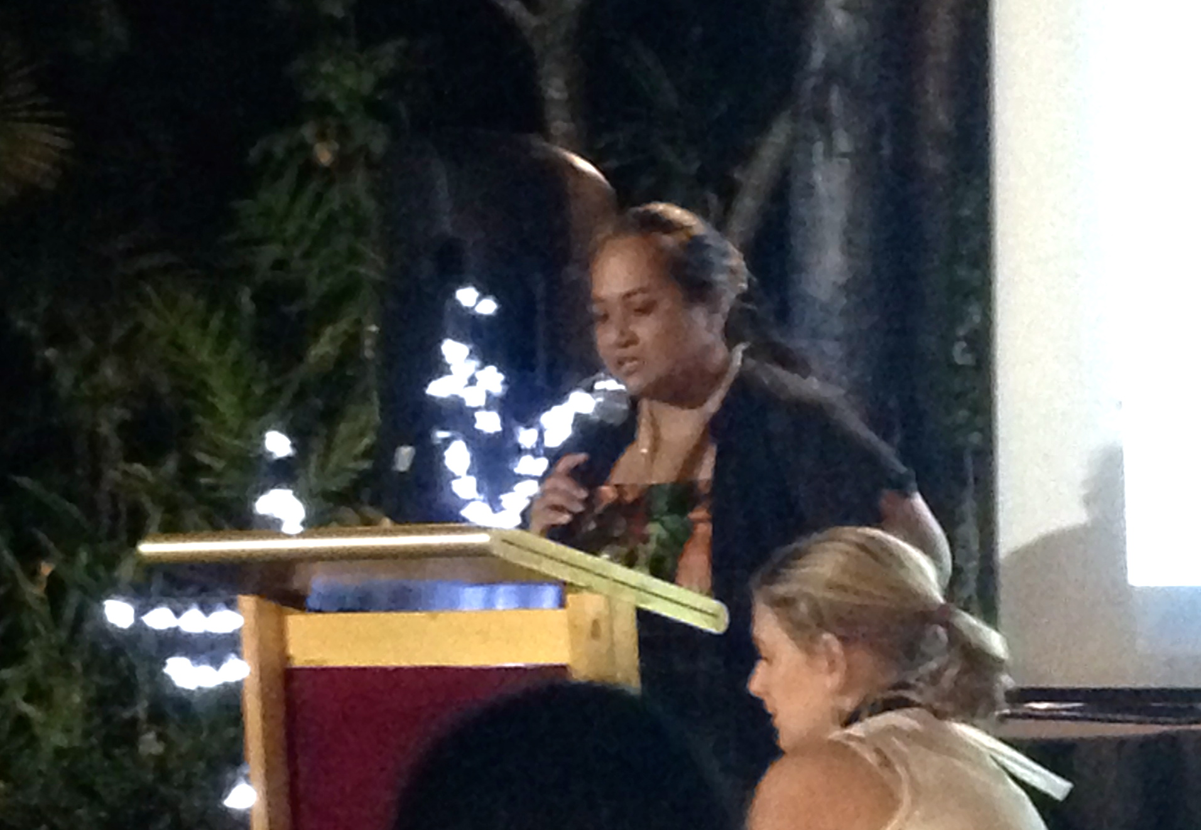
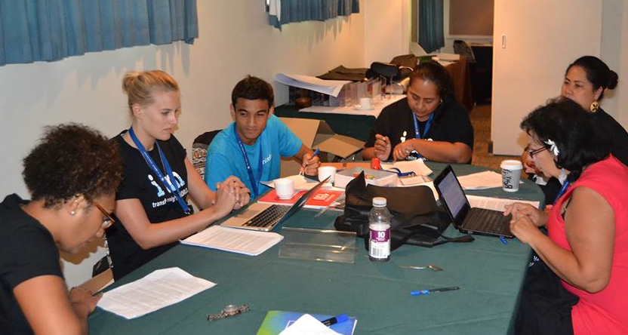

The Yogyakarta Principles are principles on the application of International Human Rights Law in relation to sexual orientation and gender identity. <http://www.yogyakartaprinciples.org>
PSIDS statement at OWG11.
Statement by Righting Finance Initiative on “Co-Creating New Partnerships for Financing Sustainable Development” <http://www.rightingfinance.org/wp-content/uploads/2014/04/Read-full-statement.pdf>
Statement on World Oceans Day June 2014, Biliana Cicin-Sain, President, Global Oceans Forum
United Nations Convention on the Law of the Sea
Women’s Major Group statement for the 12th session of the Open Working Group on Sustainable Development Goals
12th Triennial Conference of Pacific Women
Women’s Major Group
Women’s Major Group
The Convention on the Elimination of All Forms of Discrimination against Women (CEDAW) and its Optional Protocol; the Beijing Platform for Action, the outcome documents of the twenty-third special session of the General Assembly, and the declarations adopted by the Commission on the occasion of the tenth and fifteenth anniversaries of the Fourth World Conference on Women. The Cairo Program of Action, the Yogyakarta Principles, the Convention on the Rights of the Child, the Convention on Rights of Persons with Disabilities, Security Council Resolutions 1325, 1820, 1888 and 1960, and the relevant conventions of the International Labour Organization, that obligate our States to adopt legal and policy frameworks for the elimination and prevention of all forms of sexual and gender based violence.
Women’s Major Group

