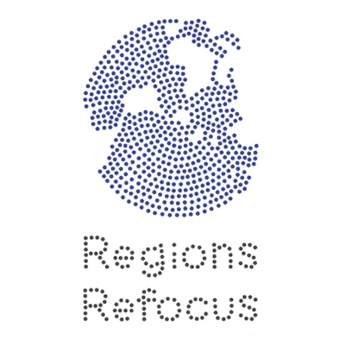

Regional Policy Positions: Arab States Post-2015 Positions on Investment, Taxation, and Social Protection

Regions Refocus, an initiative housed at the Dag Hammarskjöld Foundation, has compiled below the proposals of Arab States, articulated in the Open Working Group (OWG) on Sustainable Development Goals (SDGs) and the Arab High-Level Forum on Sustainable Development (regional preparatory meeting for the High-Level Political Forum), related to the main themes of the meeting “Addressing Social and Economic Inequalities: The need for a new development paradigm,” 14-16 June, in Beirut, Lebanon. The agreed language listed in the right column comes from the outcome document of the OWG (July 2014) and the Intergovernmental Committee of Experts on Sustainable Development Financing (ICESDF, August 2014).

For more detail on the OWG positions, see the background document at http://bit.ly/1ldrnSu.
For more detail on the Arab High-Level Forum on Sustainable Development, see the background document at http://bit.ly/1mGG7rg.

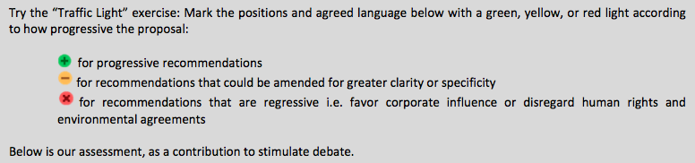

Topic | Proposals (and Proponents) | Agreed Language
Taxation | Strengthen capacities for tax collection and reducing tax evasion (Egypt)  Strengthen domestic resource mobilization, including by improving tax collection and the efficiency of public spending, reducing tax evasion and avoidance, improving stolen asset recovery, and strengthening systems to harness domestic savings for investment. (UAE)  Strengthening systems of domestic savings (Egypt)  Mobilize domestic resources including for infrastructure investment (UAE)  Promote a facilitation mechanism for the economic institutional capacities related to domestic resource mobilization (Iran)  Reduce corruption at the national and international levels and ensure equitable taxation and redistribution of assets. (Tunisia) | International support to developing countries to improve domestic capacity for tax and other revenue collection (OWG)  Prioritize real income gains at the bottom of the income distribution through progressive tax policies and VAT exemptions on basic goods and services. (ICESDF)  Capacity development measures for developing countries could increasingly focus on international taxation issues. (ICESDF)
Social Protection | Develop and promote social protection floors for all members of society, taking into account national needs and circumstances (UAE)  Adopt progressive social policies and protection systems, including universal social protection floor that includes all social groups, persons with disabilities and geographical regions is needed. (Arab High-Level Forum)  Provide social protection and social protection floors. An estimation of the cost of such target should be done, as well as the potential sources of providing such funds. (Tunisia)  Provide and enhance social protection systems to improve the resilience of all (LDCs)  Strengthen institutional capacity for effective delivery of services (UAE) | Implement nationally appropriate social protection systems and measures for all, including floors, and by 2030 achieve substantial coverage of the poor and the vulnerable (OWG)  Recognize and value unpaid care and domestic work through the provision of public services, infrastructure and social protection policies, and the promotion of shared responsibility within the household and the family as nationally appropriate (OWG)  Adopt policies especially fiscal, wage, and social protection policies and progressively achieve greater equality (OWG)  Countries should consider policies to strengthen “social protection floors”, which, as per the findings of the International Labor Organization are affordable in most countries out of domestic revenues, but warrant international assistance for the poorest. (ICESDF)
Investment Policies | The promotion of Foreign Direct Investment is an important aspect of the good governance at the international level. (Morocco)  Enhance the mobilization of domestic resources and foreign investment to achieve at least 40 per cent investment to GDP ratios in LDCs against the current rate of 22 per cent. (LDCs)  Control and regulate speculation in the commodities markets, including through ensuring favourable terms for commodity-dependent Domestic Companies in contracts with Trans-National Companies to enable them to add more value to commodities and obtain more revenues from commodity-related activities (Egypt, African Group)  Regulate systemically important financial institutions and markets, including international banks and rating agencies and markets for commodity derivatives with a view to reducing international financial instability and instability of commodity prices (Egypt) | Adopt and implement investment promotion regimes for LDCs (OWG)  Encourage and promote effective public, public-private, and civil society partnerships, building on the experience and resourcing strategies of partnerships (OWG)  Enhance the global partnership for sustainable development complemented by multi-stakeholder partnerships that mobilize and share knowledge, expertise, technologies and financial resources to support the achievement of sustainable development goals in all countries, particularly developing countries (OWG)  International public finance will also have an important role in financing investments in national development, such as infrastructure. Some of these investments are profitable, and international public finance can catalyze private financing for sustainable development in such areas. (ICESDF)
Global Economic Governance | Establish a new international agency with full and equal participation of developing countries in order to regulate systemically important financial institutions and international capital flows (Egypt)  Enhance the accountability of countries for the trans-boundary negative implications of their financial and economic policies and practices (Iran)  Undertake a comprehensive review at the UN level of the working methods of the international credit rating agencies and establish transparent standard norms for their work at the global level, with a view for fostering accountability, transparency and competition in the credit rating agency at national and global levels (Tunisia)  Strengthen regulation of financial markets and institutions to ensure global financial stability (Egypt, Iran, African Group)  Establish effective regulation and supervision over financial institutions and markets, including control over international capital flows and private sector borrowing abroad. (Egypt)  Reform the international monetary system to support sustainable development and addressing the shortcomings in the exchange rate and the international reserves systems (Egypt, African Group)  Underline the importance of improving global economic governance and strengthen the United Nations’ leadership role in promoting development (G77/China) | Broaden and strengthen the participation of developing countries in the institutions of global governance (OWG)  A further review of the governance regimes of the IFIs is necessary to update their decision making processes, modus operandi and priorities, and to make them more democratic and representative. (ICESDF)  The IMF and the World Bank have been making efforts to further integrate the voices of emerging market and developing countries, to reflect their growing importance in the global finance and development arena. These efforts should be brought to fruition. (ICESDF)
Trade | Promote an open, rules-based, non-discriminatory and equitable multilateral trading system with duty-free and quota-free market access for all LDCs on a preferential basis (LDCs)  At least double the share of exports of LDCs and other developing countries witnessing structural trade deficits in global exports by 2020. (Tunisia)  Improve the climate for trade for developing countries, and ensure that trade and trade rules work to the benefit of developing countries and to help meet their development objectives (Egypt, African Group)  Maintain the development dimensions and concerns in the Doha Round and on that basis to continue the negotiations in WTO until their successful conclusion (Egypt)  Enhance trade related capacities of developing countries including trade-related infrastructure, trade facilitation and trade finance. (Morocco)  Increase support for trade-related capacity development of developing countries including in trading services; enhance ability of developing countries to diversify their economies and exports, to capture a greater part of value-added production, and to improve their international competitiveness particularly of SMEs (Tunisia)  Ensure that trade and investment agreements enable rather than discourage or detract from policy space in developing countries that is required for their development (Egypt, African Group)  Review multilateral rules and agreements as well as trade and investment bilateral agreements with a view to improving the policy space in developing countries in pursuit of the above national objectives (Egypt)  Discourage the proliferation of bilateral FTAs that encroach on policy space of developing countries and divert trade from the multilateral arena (Egypt) | Promote a universal, rules-based, open, non-discriminatory and equitable multilateral trading system under the WTO including through the conclusion of negotiations within its Doha Development Agenda (OWG)  Increase significantly the exports of developing countries, in particular with a view to doubling the LDC share of global exports by 2020 (OWG)  Realize timely implementation of duty-free, quota-free market access on a lasting basis for all least developed countries consistent with WTO decisions, including through ensuring that preferential rules of origin applicable to imports from LDCs are transparent and simple, and contribute to facilitating market access (OWG)  Correct and prevent trade restrictions and distortions in world agricultural markets including by the parallel elimination of all forms of agricultural export subsidies and all export measures with equivalent effect, in accordance with the mandate of the Doha Development Round (OWG, ICESDF)  Increase Aid for Trade support for developing countries, particularly LDCs, including through the Enhanced Integrated Framework for LDCs (OWG)  To further facilitate the participation of the poorest countries in the international trading system, in accordance with their own nationally owned strategies, “aid for trade” and the Enhanced Integrated Framework for assisting developing countries and LDCs in particular are of central importance. Trade-related technical assistance, capacity building and trade facilitation and efforts to mainstream trade into development policies should all be reinforced. (ICESDF)  In general, the proliferation of bilateral investment treaties and other trade agreements covering investment issues renders the mainstreaming of a sustainable development perspective in investment regimes more difficult…. Steps should be explored toward a multilateral approach to international investment regimes that more adequately balances investors preferences with the needs of residents of the countries in which they would operate, with a view to facilitating a more holistic approach in the interest of sustainable development. (ICESDF)

