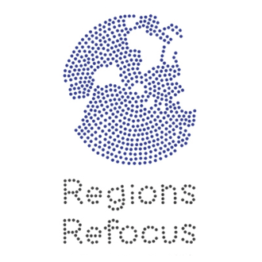
Post-Colonialisms Today
A project to recapture post-Independence African agency and progressive policies for our times

CONCEPT NOTE
Initial Researchers’ Meeting
28-29 April 2018, Dakar, Senegal

The first research meeting of the Post-Colonialisms Today project will be held in Dakar, from 28-29 April 2018. Bringing together authors of research proposals, members of the Post-Colonialisms Today project Working Group, advisors to the project, and other individuals of interest, the meeting will discuss the selected research proposals and issues related to the research. The aim is to collectively adopt a set of understandings to kick off the research phase of the project.

The Post-Colonialism Today project is aimed at examining policies adopted and/or formulated by governments and (inter-governmental) institutions in Africa in the immediate post-Independence period with a view to changing the structures of political economy inherited from colonialism, so as to fulfil the popular aspirations of the anti-colonial movement. The premise of the project is that, driven in effect by African agency, and formulated in response to the specific constraints on these countries deriving from their (colonialist-constructed) place in the international political economy, the policies then formulated and/or adopted were relevant to the challenges of Africa's socio-economic transformation, even though they had their own limitations. Compared to this, the subsequent period of neo-liberalism has been a costly diversion.

The purpose of the project is to recover (samples of) these policies, and, by applying heterodox and feminist analytical approaches, learn which part of these policies can be applied today as part of the efforts to transcend the acknowledged ravages of four decades of neo-liberal dogma in Africa and its failures. In broad terms, this essential thrust and purpose of the project is adequately captured in the concept note of the project as well as in the call for proposals, and is similarly reflected in the majority of the proposals submitted in response to the call.

Nevertheless, to effectively translate the essence of the project into appropriate research outcomes, it remains to more concretely frame the parameters of the project and adopt methodologies for the intended research. The research meeting is aimed to meet this objective, and to do so collectively. To this end, the meeting will:
(a) discuss the conception of the project and its key assumptions, to develop a shared and more concrete framework of expectations to guide researchers and others involved in the research;
(b) outline some of the key political currents and their theoretical expressions which formed the policy context of the period under consideration;
(c) discuss the specific research proposals;
(d) adopt methodological perspectives to guide the research; and
(e) formulate terms of reference for the researchers.

Format
The two-day meeting will be organized in a combination of discussions in plenary (including panels), small groups and one-on-one. These will be organized around the following main segments:
(a) The Project:
(i) project essence, objectives and key assumptions
(ii) political and intellectual context of policy in the relevant period
(c) Research Proposals – presentations and feed-back
(d) Research Methodologies
(i) Heterodox Approach
(ii) Feminist Approach
(iii) Specific Methodological Considerations

