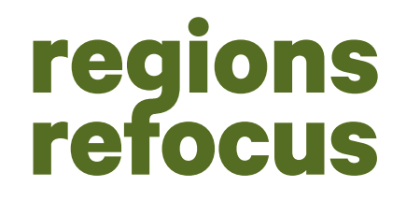
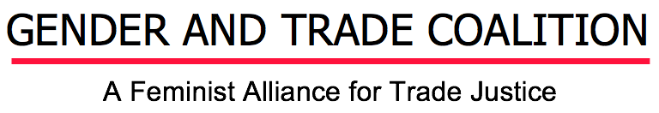

Historicizing and Advancing Feminist Trade Advocacy at CSW63

On the first anniversary of the inception of the Gender and Trade Coalition (GTC), members came together at the 63rd UN Commission on the Status of Women for a full week of events. Maximizing on the rare opportunity to convene in the same space, the week was anchored by a two-day Strategy Meeting aimed at deepening the Coalition’s analysis, formalizing a governance structure, and planning action around policy alternatives. The Strategy Meeting was bookended by the public launch of the Coalition and a side event convened in partnership with UNCTAD, ‘Ensuring Gender Just Trade: Challenges and Ways Forward.’

A key theme that threaded through all three events was the need to situate the Gender and Trade Coalition in the rich, decades-long history of feminist organizing for trade justice. At the Launch, Gita Sen (DAWN) spoke to the legacy of the original International Gender and Trade Network (IGTN), a coalition of feminist groups that mobilized in 1999 around some of the earliest analysis on the intersections of gender and trade.

Mariama Williams (The South Centre) noted much of this history has been eroded with the emerging interest of global institutions in gender. Organizations like the WTO are positioning themselves as pioneers in this space, adopting the language of gender equality to mask continued efforts to open and deregulate markets in the global South for Northern corporate capture. In contrast with the IGTN’s struggle to expand the global trade agenda to recognize gender, the GTC is in the position of reacting to this instrumentalization of women as a tool for liberalization.

The side event made evident the challenges of promoting a transformative agenda in a context where previous feminist demands haves been appropriated by mainstream institutions without regard for the harmful consequences of trade policy on women’s rights. The conversations in this space, between UNCTAD and government representatives, GTC members, and other civil society actors, were underpinned by fundamental questions of what constitutes gender-just trade policy and how to progress towards it. In a detailed intervention, Natalie St Lawrence from the Canadian Department for Women and Gender Equality spoke to her government’s pursuit of gender justice through gender chapters in trade agreements, the integration of gains for women throughout these agreements, and the development of laws to address their potential consequences, such as labor market transition.

Panelists --including Mariama Williams (The South Centre), Isabelle Durant (UNCTAD), Sheba Tejani (The New School), and Sanam Amin (APWLD)-- constructed a more expansive notion of gender justice that reflects the totality of women’s lived experiences. Isabelle Durant spoke to the need for ex ante evaluations for every chapter of a trade agreement to assess potential outcomes for women. Mariama Williams suggested agreements must also be contextualized in a broader consideration of the economy, including access to public services and infrastructure. In this vein, she questioned whether Canada’s feminist trade agenda includes reforming bilateral trade agreements that allow corporations to sue developing countries, often undermining public provision in ways that acutely harm women. Sheba Tejani (New School) similarly expanded the scope of available policy instruments, pointing to the importance of complementary industrial policy to ensure productivity-driven wage growth, and suggesting the policy process is itself a site for the inclusion and upliftment of women. With multiple actors speaking the language of gender-just trade policy, this dialogue highlighted the importance of asking which women the policies in question include, within what parameters, and towards what end.

The GTC is mobilizing, in many ways, in a significantly different economic landscape to that of feminist struggles 20 years ago. Members at the Launch and Strategy Meeting began mapping the contours of this new landscape. At the Strategy Meeting, Graciela Rodriguez (Instituto Equit - Gênero, Economia e Cidadania Global) spoke of the mutating models of capitalist accumulation due to the growing digital economy and financialization of daily life, which is reshaping women’s economic realities. Ranja Sengupta (Third World Network) drew attention to the WTO replacing differential treatment for developing countries with horizontal provisions for constituencies like women, which simply expand opportunities for elite groups of women in the North while exacerbating the conditions in which women in the global South suffer by continuing to shrink state capacity to pursue their development objectives. At the launch, this analysis provided context for the re-awakening and rethinking of feminist solidarities for trade justice through the GTC; at the Strategy Meeting, it was channeled into collectively building a governance structure and advocacy plan.
In 2019-2020 and beyond, the Coalition plans to advance our shared mission at the High Level Political Forum, International Association For Feminist Economists, Global Review of Aid for Trade, WTO Public Forum, and ECLAC Regional Conference on Women to name a few arenas. Please consider joining us by signing our unity statement.

